PHYSIOLOGY SUMMARY

Only two systems control the human body functions; the nervous system(for immediate action) and the endocrine system (for delayed action).
Characteristics | Endocrine system | Nervous system
Mechanism of control | Hormones are usually delivered directly in the blood to tissues. | Neurotransmitters are released in response to nerve impulses and move from: neuron to neuron, neuron to muscle cell , or from neuron to gland cells.
Affected cells | Almost all cells in the body | Nerves, muscles & glands
Types of actions | Changing in the metabolism either anabolism or catabolism | Neuron to Neuron: action potential in the 2nd nerve .  Neuron to muscle: muscle contraction .  Neuron to glandular cells: secretions of enzymes or hormones .
Time to onset of action | Usually delayed, but sometimes immediate | Usually immediate
Duration of action | Generally longer | Generally brief

Types of glands:
1)Exocrine glands: their secretions are released into a duct which opens either inside the body(into a lumen) such as the intestines or outside the body, such as sweat glands.
2) Endocrine glands: there’re 2 types :
**Classic endocrine glands ( ductless) >> they release their secretion directly into the blood and their hormones are also called classic hormones.
**other endocrine glands : don’t release their secretions directly into the blood ,e.g; autocrine & paracrine glands.
3) Neuroendocrine : either the hormone is produced by neurons & released directly into the blood( e.g; the post. pituitary) or the hormone is produced by neurons and released into the cleft affecting postsynaptic neurons ( e.g; noradrenaline).

**Pheromones : volatile hormones released into the environment to act on olfactory cells of other individuals . Females usually produce such hormones more than males do.

NOTES:
- A single endocrine gland may produce many hormones under different control mechanisms with different functions(e.g; ant. Pituitary & pancreas)
- Most hormones have pleiotropic effects ( i.e they have multiple actions in their target tissue).e.g; insulin in the skeletal muscles.
- Some hormones have several effects in different target tissues . E.g; testosterone, which is responsible for normal spermatogenesis in the testes and stimulation of growth of accessory sex organs.
- The same chemical messenger can be classified as a hormone or a neurotransmitter depending on the source, e.g; somatostatin; if secreted from the pancreas then it’s considered as a hormone, while if produced by the hypothalamus ,then it’s called neurotransmitter
- Multiplicity of regulation in the endocrine system ( e.g; many hormones regulate liver glycogen metabolism such as insulin, glucagon, epinephrine, cortisol, and thyroid hormones.)
- Single target cell may be influenced by more than one hormone(e.g; liver).
- Some organs are specialized in hormonal secretion only, while others have non-endocrine functions in addition to hormonal production (e.g; intestines, stomach, ovaries & testes etc.. )
- Many target cells regulate their response by changing the number of receptors or regulating receptor function >> the cell becomes less responsive upon the chronic exposure to a hormone, which is called desensitization .
** homologous desensitization: if the exposure of the cells to a hormone had a desensitizing effect on the terminal action of that hormone.
** heterologous desensitization: if the exposure of the cells to a hormone had a desensitizing effect with regard to a different hormone.

- The general functions of hormones:
- Metabolism. – Reproduction
- Digestion - Transport of substances to tissues.
- Defense against pathogens. – Growth
- Stress response. – Behavior
- Blood circulation: control our cardiac output, blood volume, BP….

***In physiology, hormones are classified into 3 categories :
- Proteins : either small or large molecules( >20 a.as)
- Amino acid derivatives : catecholamines ( adrenaline, noradrenaline & dopamine) and thyroid hormones.
- Steroids : sex hormones & adrenal cortex hormones .

- Regulation of hormonal secretion :
- Feedback Control : the relation between the response & the stimulus [stimulus-response] , which could be :
Either [hormone-hormone] or [ substrate-hormone] like glucose-insulin or [mineral-hormone] like Calcium-PTH .
** when the response increases the stimulus >> positive feedback .e.g; more & more uterine contractions during delivery result in more & more oxytocin release.
** when the response decreases the stimulus >> negative feedback, which occurs in three loops :
- Ultrashort loop >> E.g; the hypothalamus secretes a hormone & that hormone affects the hypothalamus ( autocrine).
- Short loop >>E.g; hormone from the pituitary affects the hypothalamus.
- Long loop >> E.g; Thyroid hormone affects the hypothalamus.

- Neural Control : hormones ( such as adrenaline , ACH, serotonin … ) are secreted neurally during special conditions ,like: pain, fright, stress & injury, etc …
- Chronotropic Control : this control is dictated by rhythms that may be genetic or acquired :
- Diurnal rhythm/ sleep-wake cycle : e.g, the highest secretion of GH is at 12 mid noon and 12 midnight .
- Menstrual rhythm : it’s genetically determined . The levels of estrogen,progesterone, LH & FSH vary during the 28-day cycle.
- Seasonal rhythm : mostly seen in mammals .e.g; the secretion of sex hormones & gonadotropin, which is genetically determined and varies according to the season.
- Developmental rhythm : there’s a variation in the secretion of GH during childhood, puberty, adulthood …..

** Again, long exposure of the cells to a hormone results in either reduction in the number of hormone receptors per cell or reduction in the affinity of the receptors to hormones.
- In down-regulation, most probably the receptors sink down inside the cell, or the synthesis of receptors decreases, or both. In up-regulation the opposite occurs.
- Example: many obese individuals have high conc. Of insulin but still have high conc. Of glucose, why? Because the insulin can’t function properly due to the small num. of receptors or the decreased affinity of its receptors >> leading to diabetes mellitus type 2.

Hormones don’t function separately, there's some kind of interaction between them in several ways:
- Permissive Effect : E.g; when thyroxine binds to its receptors on fat cells & increases the num. or the affinity of receptors to adrenaline.
- Synergistic Effect : e.g; lactogenic, galactokinetic, mammogenic hormones function together to produce the best outcome.
- Antagonistic Effect: a hormone opposes the action of another hormone on the same cell such as; insulin & glucagon, PTH & calcitonin .

Mechanism of action of hormones:
- Production of cAMP : some hormones that can't penetrate the cell membrane need a 2nd messenger to transmit the message. One of these 2nd messengers is the cyclic AMP.
The pathway is as the following: hormone binds a receptor >> activates G protein in the membrane >> alpha subunit binds GTP and detaches from beta & gamma subunits >> activation of adenylate cyclase which converts ATP into cAMP .
- Activation of phospholipase C : seen in hormones that need calcium for their function
The pathway : hormone binds a receptor >> activates G protein in the membrane >> alpha subunit binds GTP and detaches from beta & gamma subunits >> activation of phospholipase C which cleaves PIP2 into DAG & IP3.
Hormones that use adenylate cyclase-cAMP 2nd messenger system | Hormones that use phospholipase C 2nd messenger system
ACTH. Catecholamines( beta receptors)  CRH. Calcitonin  FSH. Angiotensin 2  LH. ADH ( vasopressin)  PTH. Secretin  TSH. Somatostatin  HCG. Glucagon | Angiotensin 2  Catecholamines ( alpha receptors)  GnRH  GHRH  Oxytocin  ADH  TRH

- Diffusion into the cells : such as steroid hormones and thyroid hormones, they bind their receptors inside the cell ( either in the cytoplasm or in the nucleus) .
- NOTE : The action of the hormones that bind to receptors inside the cells is a delayed action , but sometimes we need a fast action for estrogen & progesterone hormones for e.g; therefore, they must have some receptors in the cell membrane so as to function immediately.

The pituitary gland :
Small gland, weighs 1g only, 1 cm in diameter, and lies in a cavity at the base of the brain called sella turcica..
It's composed of 2 parts; anterior ( adenohypophysis) and posterior (neurohypophysis).

-The function of the post. Pituitary is only a storage function ( hormones are produced in neurons of the hypothalamus and are stored in the post. Pituitary) .
-Hormones of the post. Pituitary are :
- ADH ( vasopressin) : from the supraoptic nucleus.
- Oxytocin : from the paraventricular nucleus.
** they have very similar structures. Also, they can do same functions but with different potencies :
ADH is more potent as an anti-diuretic than oxytocin is, with a ratio of 200:1
Oxytocin is more potent as milk ejector than ADH is, with a ratio of 100:1

-Functions of ADH :
- Increases reabsorption of water from the renal tubules.
- Constriction of blood vessels, and that’s why it’s called vasopressin.

Major ADH stimuli | Major ADH inhibitors
Increased serum osmolarity | Decreased serum osmolarity
Decreased ECF volume | Increased ECF volume

-The ant. Pituitary is indirectly connected to the hypothalamus. The releasing or inhibiting hormones are first produced by the hypothalamic neurons and then released into capillaries at the median eminence till they reach the ant. Pituitary.
So unlike the post. Pituitary, none of the ant. Pituitary hormones are of hypothalamic origin >> they’re not under the direct neural control.
** The hypothalamic hormones can reach the ant. Pituitary via 2 routes:
- The long pathway( for slow action): neurons release their hormones in the median eminence capillary bed >> travel by the long portal vessels to the adenohypophysis.
- The short pathway (for fast action): neurons release their hormones in the post. Pituitary >> they travel to the adenohypophysis by short portal vessels.

- Cells of the anterior pituitary :
- Somatotrophs ( 30-40%): the most abundant type, produce growth hormones.
- Corticotrophs(20%) : produce ACTH.
- Thyrotrophs : produce TSH.
- Gonadotrophs: produce FSH & LH.
- Lactotrophs( mammotrophs): produce prolactin.
NOTE: Each cell type produces one hormone, but there’re exceptions: 1-sometimes somatotrophs produce GH & prolactin 2- gonadotrophs produce FSH only or LH only normally or abnormally.

-The hypothalamic hormones: ( all of them are proteins except dopamine)
-CRH : stimulates ACTH release. –TRH: stimulates TSH & prolactin release.
-GHRH: stimulates GH release. –Somatostatin: inhibits GH release.
-GnRH: stimulates FSH,LH & dopamine release .
** the hypothalamic releasing hormones exert more control, but for prolactin, the hypothalamic inhibiting hormones exert more control because it’s not needed in both sexes.

- Growth Hormones:( somatotropins)
They target all body cells.
There are other hormones that have roles in growth,such as : insulin-like growth factor 1&2 ,insulin, THs, glucocorticoids, androgens & estrogens.
NOTE: GHs and IGF-1 are the major determinants of growth in post-uterine life.
-Insulin & GHs act synergistically to promote our normal growth & development.
-The direct effects of growth hormone on :
1) Adipose tissue | 2) Liver | 3) Muscles
decreases glucose uptake & Increases lipolysis | Increases RNA synthesis >> high protein synthesis. Increases gluconeogensis and somatomedin production. | Decreases glucose uptake, increases a.as uptake and protein synthesis.

-Metabolic effects of GH : increases protein synthesis and the mobilization of F.As, and decreases the rate of glucose utilization throughout the body.

-Effects of hypersecretion of GHs :
- Diabetogenic Effect: high secretion of GH >> high blood glucose level >> exhaustion of beta cells that secrete insulin ( direct effect of GH on beta cells).
- Ketogenic Effect: excessive secretion of GH >> great amount of F.As are produced >> lots of acetoacetic acid are formed by the liver >> ketosis.
*** NOTE : there’re hormones other than GH that have diabetogenic effects, such as; TSH, prolactin, ACTH, & cortisol.

- The levels of GH, insulin, and somatomedin in :
-Protein intake >> high levels of GH,insulin, & somatomedin.
-Carb. Intake >> high levels of insulin ONLY.
-Fasting >> high levels of GH ONLY.

Stimulants of GH | Inhibitors of GH
Decreased blood glucose | Increased blood glucose
Decreased F.As | Increased F.As
Increased a.as | Aging
Starvation & fasting | Obesity ( important)
Protein deficiency | Leptin
Stress & excitement
Ghrelin

Notes: Ghrelin is a hormone released by the stomach during fasting and induces appetite.
Leptin is produced by fat cells, and in higher levels in obese people. It inhibits food intake.
GI hormones such as peptide YY, insulin, and cholecystokinin suppress food intake.

-Hyposecretion of the pituitary:
Panhypopituitarism | Severe anterior pituitary deficiency | Moderate anterior pituitary deficiency | Mild anterior pituitary deficiency
-Deficiency in all pituitary hormones, which results in :  * Diabetes insipidus : due to ADH deficiency ( water isn’t reabsorbed)  * Absence of gonadotropins( FSH &LH); in males: no testosterone, decreased libido, no sperms, hair loss . in females: amenorrhea, decreased libido.  * Atrophy of the thyroid gland due to TSH deficiency  * Atrophy of the adrenal cortex atrophy due to ACTH deficiency.  * pallor color due to MSH deficiency  * Dwarfism due to GH defiecincy. | Similar to panhypopituitarism except that the post. Pituitary hormones are normal. | -Gonadotropins and TSH are deficient .  -ACTH & MSH are partially deficient  -GH IS NORMAL . | Only gonadotropins are deficient , the others are normal.

Note: in diabetes insipidus, the urine appears pale, unlike diabetes mellitus in which the urine appears dark.
** Notice that gonadotropins are affected in all conditions of pituitary deficiency.

-Hypersecretion of the pituitary:
Gigantism | Acromegaly
-The hypersecretion occurs during childhood.  Almost all organs will be affected & are larger than normal.  -Giants have hyperglycemia >> 10% develop Diabetes mellitus.  -If left untreated, they’ll develop panhypopituitarism.  -All parts of the body will be enlarged but in appropriate proportion. | -The hypersecretion occurs after the fusion of long bones >> so the long bones cant grow further but the soft tissue( liver, tongue..) & small bones ( nose, forehead, hands, feet, the lower jaw …) can continue growing.  -There’ll be an increase in the thickness of the bones leading to osteopetrosis.  -There’s no appropriate proportion in the development

The adrenal ( suprarenal )glands :
-They’re essential for life. If they were removed, the individual dies.
-They’re composed of 2 parts; cortex (80%) & medulla(20%). Actually, removal of the adrenal cortex is of disastrous consequences, whereas removal of the medulla can be tolerated.
-ACTH is the controller of adrenal cortex, and its main target hormone is cortisol.
** The main stimuli for ACTH secretion are CRH & ADH.
-ACTH secretion responds mostly to stressful stimuli(sth. That is critical to survival).

ACTH has extra-adrenal functions like lipolysis & MSH-like action.
** ACTH stimulates the production of cAMP >> activates other enzymes>> Then an enzyme catalyzes the conversion of cholesterol => pregnenolone ( the most important step in adrenal cortex hormones synthesis) .
If cortisol synthesis is blocked at the last step, corticosterone level increases in the blood

-Functions of the adrenal cortex:
- Controls Na+, K+, and water metabolism, thus it affects blood volume and consequently the blood pressure.
- Controls carbs, fat, and protein metabolism
- Participates in responses to stress of various kinds.

-The adrenal cortex is composed of 3 zones:
- Zona Glomerulosa : produces mineralocorticoids , mainly Aldosterone.
- Zona fasiculata : produces glucocorticoids ( the representative is cortisol), it produces small amounts of androgens as well.
- Zona reticularis : produces androgens & estrogens as well as small amounts of cortisol . This zone doesn’t develop properly until the age of 8.

NOTES:
-The rate of cortisol secretion is higher than that of aldosterone.
-The role of cortisol in minerlacorticoid activity is much higher than the role of aldosterone in glucocorticoid activity due to the difference in their rates of secretion.
-The variation in cortisol secretion is parallel to the variation in ACTH levels. The high levels of cortisol are during daytime, not during midnight.

** When adrenal cortex hormones are synthesized, they’re released immediately. So, they aren’t stored in the cortex >> this means that any need for these hormones requires a new synthesis.
- Cortisol:
90% is bound to corticosteroid-binding protein (transportin), 6% is bound to albumin, 4% represents the free portion.
-It has many effects:
- Production of glucose from non-carbohydrate sources.
- Modulation of CVS function( by maintaining sensitivity to vasoconstrictive agents).
- Increases the mobilization of glycerol & F.As from adipose tissue.
- Modulation of CNS function.
- It affects glycogenolysis ,but indirectly; it facilitates the action of glucagon (permissive action) .
**Conclusion: cortisol plays a role in the defense against hypoglycemia by 2 ways:
- Production of glucose from non-carbohydrate sources.
- The permissive effect in glycogenolysis along with glucagon.

** Cortisol is important in the fetus, how ??
- Production of surfactants from type2 cells of the alveoli- a lack of which leads to the RESPIRATORY DISTRESS SYNDROME in newborn infants.
- Development of the hypothalamic function & thyroid-pituitary axis.
- Initiation of endocrine changes in the fetus & mother which are responsible for delivery. Also, important for the sequential changes of placental structure.
- Development of hepatic enzymes( including those involved in gluconeogenesis).
- Induction of thymic function.

We have natural glucocorticoids ,such as:
-Cortisol: 95% of glucocorticoid activity, very potent.
-Corticosterone: 4% of total glucocorticoid activity, less potent.
And synthetic glucocorticoids, such as: Cortisone, prednisone, methylprednisone, and dexamethazone.
>> The effect of these drugs follows personalized medicine rules. They can be used basically to treat diseases that are related to almost all body systems since they are steroids( they can get into all types of cells).

- Aldosterone:
20% is bound to corticosteroid-binding protein(transportin), 40% is bound to albumin, 40% represents the free portion.
-The main function of aldosterone is to regulate Na+ levels in the body, it causes Na+ reabsorption through renal tubules by binding to its receptors inside the cell.
- Its antagonists :1) Amiloride >> a diuretic drug that opposes aldosterone by inactivating Na+ channels. 2)Spironolactone >> a diuretic drug also that inhibits aldosterone binding to its receptor.
** NOTE : Aldosterone doesn’t cause Na+ reabsorption only through renal tubules, but also through the intestines, salivary glands, and sweat glands.

Stimuli for aldosterone secretion are :
-Angiotensin 2 ( this is the main stimulus, NOT ACTH )
-Hyperkalemia( high plasma K+ levels) and decreased Na+ levels( low blood pressure)
-ACTH. –Angiotensin 3
** The mechanism:
Low blood pressure >> renin is released from the kidneys >> it produces angiotensin 1 from its precursor ( angiotensinogen) in the liver >> Angiotensin 1 is converted to Angiotensin 2 by the action of converting enzymes in the lungs.

**Actions of angiotensin 2 :
- It causes secretion of Aldosterone which increases Na+ reabsorption (indirect effect)
- It can stimulate Na+ reabsorption directly through renal tubules in exchange with K+ parallel to HCO3- ( This occurs at the basolateral membrane) . At the luminal membrane , an exchange with H+ occurs.
- It increases BP indirectly via vasoconstriction of renal efferent arterioles. when this happens , fluid ( plasma ) in the peritubular capillary decreases . This leads to two events : Hydrostatic pressure in the peritubular capillary decreases and colloid osmotic pressure (oncotic pressure ) in the peritubular capillary increases.

** One suggested treatment for those who suffer from hypertension is to inhibit the production of angiotensin 2 from angiotensin 1 ( since angiotensin 2 stimulates the secretion of aldosterone >> Na+ reabsorption>> elevated BP) . These drugs are called Angiotensin Converting Enzyme Inhibitors (ACE inhibitors). The 1st to be marked is Captopril whose common side effect is chronic cough. More recently, drugs have been developed that specifically block angiotensin 2 receptors.

- Weak Androgens:
Dehydropiandrosterone & Androstenedione >> these produce the most potent male androgen which is testosterone.
Also, they produce Estrone & Estradiol ( estrogens) .
-When cortisol synthesis is blocked at the last step, the previously mentioned 2 weak androgens levels increase.
-These two weak androgens are not important in males in any stage of life because there is a strong male androgen that’s produced by the testes which is testosterone . But,they may be important for males only in one case , at late childhood and beginning of puberty where they have a role in expressing male characteristics ( e.g. growth of beard) and that’s why their levels increase during this period . However , in females , they are important in all life stages especially after menopause (explanation : after menopause , ovaries stop functioning so that adrenal cortex becomes the only source for androgens and estrogens)

The thyroid gland :
-TRH from the hypothalamus stimulates TSH which in turn stimulates the thyroid gland.
-Dopamine & somatostatin directly inhibit the TSH, while cortisol & GH are indirect inhibitors.
-TSH is a blood protein that is composed of 2 subunits; alpha and beta
** Alpha is nonspecific, found in other unregulated hormones like FSH,LH,CGH…
** Beta is specific, it’s the active subunit and it can’t function unless is bound to alpha.
-TSH uses cAMP as a 2nd messenger and it can also activate phospholipase C to produce DAG & IP3.

By the 12th week of gestation, the fetal thyroid gland produces thyroid hormones which are essential for the development of the nervous system & skeleton.
** IMPORTANT NOTE:
The production of THs is under the effect of the fetal ant. Pituitary & the fetal hypothalamic hormones because the maternal hypothalamic & pituitary hormones can’t pass through the placenta to reach the fetus.

- Thyroid gland is unique in 2 aspects:
- Its hormones are stored in the colloid, sufficient for the human being for at least 1 month.
- The only gland that incorporates inorganic subs. ( iodine) with organic subs.(tyrosine) during the synthesis of its hormones.
-Thyroid Hormones ( THs) :
T4 >> when 2 di-iodotyrosine bind together , it either has a little activity or not at all.
T3 >> when a di-iodotyrosine binds mono-iodotyrosine , it’s the most active form.

-Mainly, the thyroid gland produces T4(pro-hormone), which will be converted to T3 when there’s a need or to rT3( totally inactive) when there’s no need .

-Synthesis of thyroid hormones :
Iodine is taken from the plasma membrane or from inside the cells>> enters the epithelial cells >> binds to a carrier protein. >> enters the colloid in the extent of Cl- >> gets activated by peroxidase enzyme >> iodination & coupling on the tyrosine residues of thyroglobulin .
** iodination & coupling can never occur on free tyrosines found in the colloid.
** Thyroglobulin carries MIT, DIT, T3 & T4.
** when needed, these thyroglobulins are taken inside the cells through pinocytosis. Then the thyroid hormones are released by the action of lyses enzymes.

-Metabolism of thyroxin (T4):
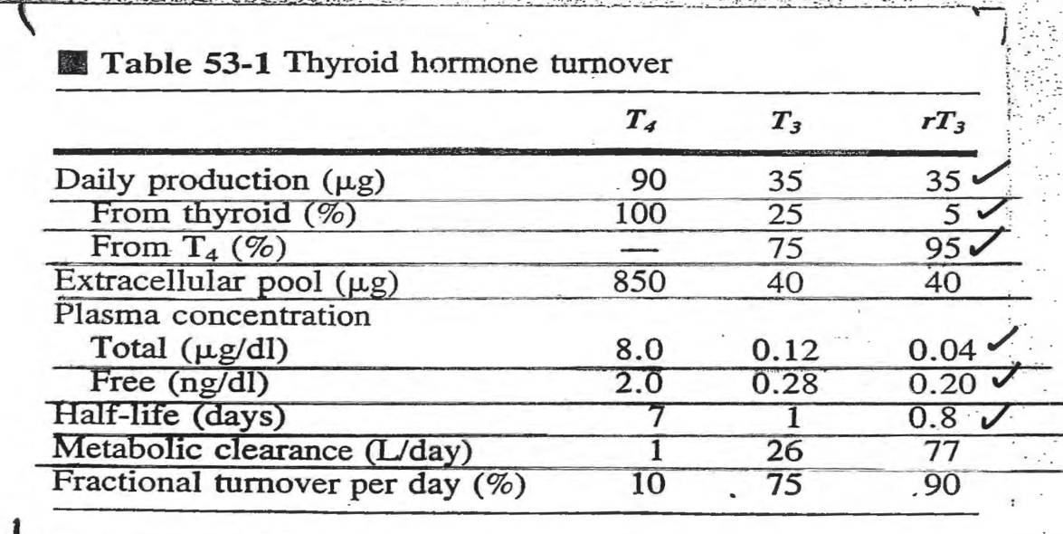
Thyroid gland produces mainly T4(pro-hormone) , which produces either T3 ( when needed) or rT3 ( when there’s no need).

99.5% of T3 is bound to proteins.
99.98% of T4 is bound to proteins.
** being bound to plasma proteins has 2 advantages: prolonging the half life of the hormone & preventing their filtration through the glomeruli. Also, THs are dangerous when they’re free.
-Types of proteins that THs can bind to :
1) TBG( thyroid-binding globulin) 2) Albumin.
3) TBPA ( Thyroxin-binding prealbumin).
** Note: T3 DOESN’t bind to TBPA.
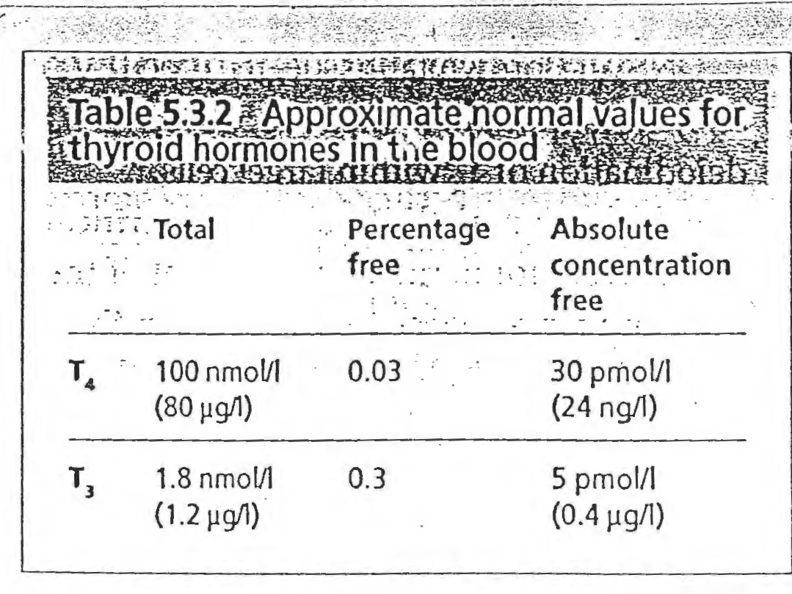

-Thyroid hormones can penetrate the cell membrane>> bind to their receptors>> activating DNA >> producing mRNA >> physiological response.
Functions Of THs | Stimulants of THs | Inhibitors of THs
Increases Na+ & K+ ATPase | TSH | Iodine deficiency
Increasing respiratory enzymes. | Thyroid-stimulating immunoglobulins | Deiodinase deficiency
Increases the consumption of oxygen >> high ventilation& high cardiac output. | Increased TBG levels ( e.g; pregnancy) | Decreased TBG levels ( e.g; liver diseases)
Increases CO2 & thermogenesis. |  | Excessive iodine intake( wolff-Chaikoff effect )
Increasing food intake |  | Prechlorate, thiocyanate ( they inhibit the iodine pump)
Increases the mobilization of fat, proteins, and carbs. |  | Propylthiouracil( inhibits peroxidase enzyme)

NOTES :
-THs & other hormones contribute in the growth process, but GH & IGF-1 are the major determinants of growth in post-uterine life.
-THs are essential in normal amounts; excess doesn’t produce overgrowth ,but only increases the catabolism in the body.
-T4 at normal conc. has permissive effect on the action of GH with regard to protein synthesis.
-Normal concentrations of THs are very low :
Total T4 = 8 mcg/dl. Free T4= 2 ng/dl ( 0.03%)
Total T3= 0.12 mcg/dl. Free T3 = 0.28 ng/dl.( 0.3%)
-Reduced thyroid activity in CHILDHOOD results in cretinism >> the fetus fails to develop the skeletal system & sexual abilities, and he’s mentally retarded.
-Pituitary dwarfism >> caused by inadequate amounts of GH. Results in abnormally slow growth & short stature with NORMAL PROPORTIONS.
-Thyroid dwarfism (cretinism)>>affects the skeletal & nervous system development and libido.Results in retarded growth, disproportionate development of bones..

Hypothyrodism | Hyperthyrodism
The most common causes are: iodine deficiency, thyroidectomy, autoimmune diseases, and radiation treatment., | Causes: Graves’ diseases(increased production of thyroid-stimulating immunoglobulins( TSIgs)), secondary to hypothalamic & pituitary secretion,or thyroid-hypersecreting tumor.
The main symptoms are:  Cretinism: if the hyposecretion occurred during childhood  Myxedema : if the hyposecretion occurred during adulthood & it’s characterized by slowing down of all body processes, such as; BMR,gut movement,appetite,body temp. falls, blood cholesterol increases, … Etc | Symptoms:  -Exophthalmus: protrusion of the eyeballs due to the overproduction of TSIgs which act against a protein of the extraocular muscles >> swelling of the Connective tissue behind the eye.  -Goiter : enlargement of the thyroid gland

Notes:
-Exophthalmus can be seen only in HYPERTHYRODISM.
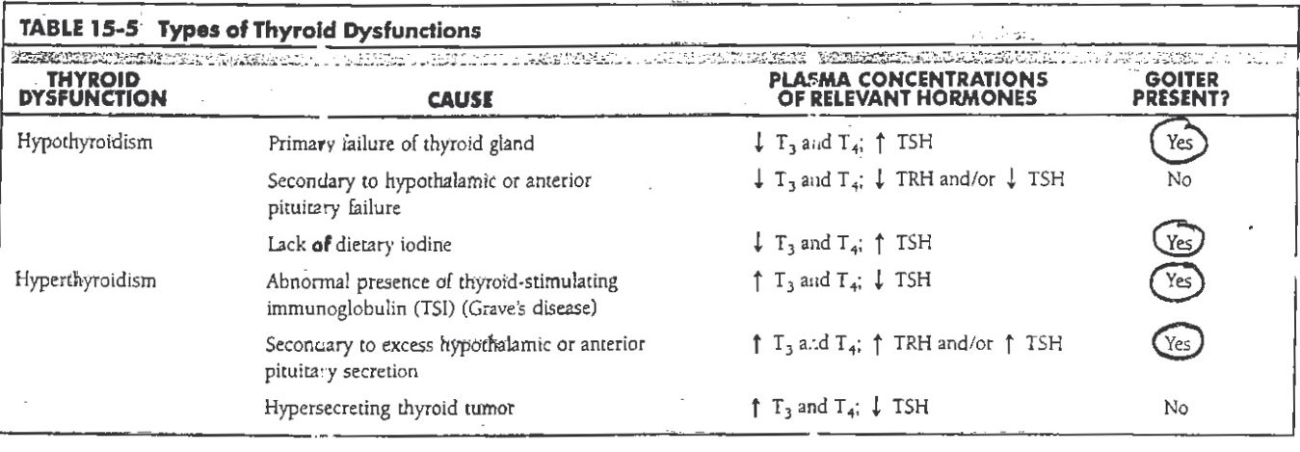
-Goiter does occur in both; hyper- & hypo-thyrodism . So, having a goiter doesn’t necessarily mean that your thyroid isn’t working normally. Even if the thyroid is enlarged, the amount of THs produced could be normal,lower or higher than normal.
** Types of Goiter :-
1)Simple benign (non-toxic): T3 & T4 levels are LOW. It’s a non-cancerous enlargement of the thyroid & it can be diffuse or nodular.
2)Malignant ( toxic ): T3 & T4 levels are HIGH. The thyroid is enlarged & there’s overproduction of THs ( hyperthyrodism ).. ****we can’t differentiate if the goiter is toxic or non-toxic depending on the appearance.

The parathyroid glands:
They’re 4 small glands located behind the thyroid gland, each one from 20-50 mg in weight. They develop at 5-14 weeks of gestation.
-There’re 2 types of cells :
1- Chief Cells >> produce MOST of the PTH.
2- Oxyphil Cells >> thought to be modified chief cells. Their function is uncertain until now, but they play a role in PTH metabolism.

** The dominant regulator of PTH is the plasma Calcium levels( not by the pituitary or hypothalamic hormones). So, Ca++ regulates the size & number of the parathyroid cells.
-Calcium should be maintained within a narrow range(10-11 mg/100ml).
-PTH has 2 types of receptors & it uses a 2nd messenger; either cAMP or DAG & IP3.
-PTH is found FREE in the plasma with a short half life of 25 mins.
** Regulators of PTH :
-Calcium levels.( the most dominant). - Vit.D.
-Magnesium. –Phosphate.
-Neurotransmitters.
- Hypomagnesemia stimulates PTH secretion, same as Ca++ but less potent.
- Increased plasma PO4-3 levels cause transient increase in PTH secretion(indirectly).
- 1,25(OH)-D reduces PTH secretion ( directly ).

** The effects of PTH :
- On Kidneys :
Increases Ca++ reabsorption & phosphate excretion.
Increases the synthesis of Vit.D which will increase Ca++ absorption from the intestines.
- On Bones :
Increases bone resorption >> more Ca++ & phosphate are released into the blood.

** The under-activity of PTH [HYPORARTHYRODISM] :
Due to atrophy or thyroidectomy..
PTH decreases >> bone resorption of Ca++ decreases, reabsorption of Ca++ from the kidneys decreases, and less absorption of Ca++ from the intestine >> collectively, they result in low Ca++ levels . If Calcium level is reduced to 5 or 6 mg/dl, megatetany will occur & if reaches the respiratory system it’ll lead to death.
How does tetanization occur?
Calcium regulates the function of Na+ channels, so in case of hypoparathyrodism Ca++ level is low >> leading to continuous opening of Na+ channels >> continuous depolarization >> contraction without relaxation >> tetany.

** The over-activity of PTH [ HYPERPARATHYRODISM] : ( Due to a tumor )
There’ll be an increase in : Ca++ reabsorption from the kidneys,bone resorption, and vit.D synthesis( increased intestinal absorption of Ca++) .
Normally, PTH induces bone resorption of Ca++ from around the bones( synovium), but excess PTH would cause its resorption from the bone structure itself causing fragility & softening of the bone >> a condition known as Osteitis Fibrosa cystica,not osteoporosis

-The second major regulator of Ca++ ( after PTH) is vitamin D.
Actually, vit.D increases both Ca++ and phosphate concentrations in plasma so that they can be deposited in the newly mineralized bone.
Sometimes, vit.D is considered as a hormone since it’s produced in the body.
It has 2 sources : Through the skin as D3 (cholecalciferol) or obtained from the diet as D2(ergocalciferol) .** Both are prohormones

D2 & D3( from the skin or the gut ) >> go to the liver & undergo identical processing to be converted into 25-OH-D (prohormone)>> this molecule goes to the kidneys where it undergoes alternative fates ;either is converted to 1,25(OH)-D or 24,25(OH)-D :-
** Deficiency of Ca++, phosphate, or 1,25(OH)-D [the active form of vit.D] , and PTH stimulation lead to the formation of 1,25(OH)-D by 1-alpha hydroxylase enzyme.
**Excess of Ca++, phosphate, or 1,25(OH)-D stimulate the synthesis of 24,25(OH)-D ,which serves to dispose the excess of vit.D, by the enzyme 24-hydroxylase.

-Actions of 1,25(OH)-D [ calcitriol ] :
- Increases Ca++ & PO4-3 absorption from the intestines.
- Increases Ca++ and PO4-3 reabsorption from the kidneys & decreases their excretion
- Promotes PTH action; when calcium levels get high, calcitriol inhibits PTH action.

NOTES:
- 24,25(OH)-D is 1/20th as potent as 1,25(OH)-D.
- 1,25(OH)-D has the lowest plasma concentration & the shortest half life.
- 25-OH-D has the highest plasma concentration & production rate.
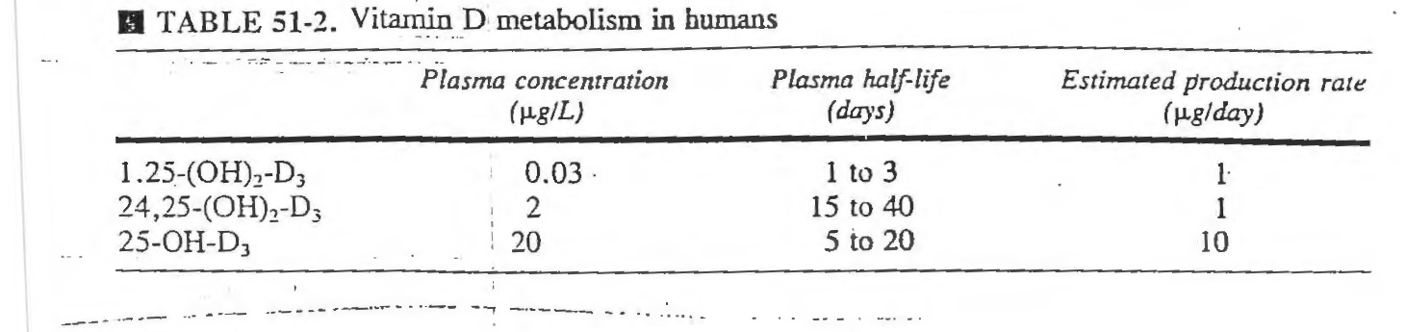
- Calcitriol can reach the following sites: mammary glands, placenta, skin, avian shell gland.

Major factors that stimulate 1,25(OH)-D | Minor factors that stimulate 1,25(OH)-D
Low Ca++ levels.  Low phosphate levels.  High plasma PTH levels. | Insulin.  Growth hormone.  Prolactin.
** Calcitriol can stimulate insulin, prolactin, and GH; thus it stimulates its own synthesis.

Notes:
- 1,25(OH)-D & 24,25(OH)-D circulate in the plasma bound to specific proteins.
- Vit.D3 has many natural sources, but vit.D2 can be only obtained form the diet.
- Vit.D is important for new bone mineralization.
- The interaction between PTH & Vit.D happens constantly so as to regulate our Ca++ blood levels .
- Vit.D is stored in adipose tissue.So, obese individuals who have lots of fat in their abdomen have their vit.D retained by this fat >> vit.D isn’t released and they’d be exposed to many heart problems.

** vitamin D deficiency :
-In children >> called Rickets
-In adults >> called osteomalacia or adult rickets.
Causes: dietary deficiency, lack of exposure to sunlight, fat-soluble vitamin malabsorption, or failure to synthesize D3 in the skin ( this occurs in dark-skinned people).

Rickets occur mainly in children who have vitamin D deficiency consequently leading to calcium and phosphate deficiency. Proper exposure to sunlight serves to prevent rickets and that is why this disease tends to occur especially in the spring months because vitamin D formed during the preceding summer is stored in the liver and is still available for use during the early winter months.
-Normal adults rarely have a serious dietary deficiency of vitamin D or calcium because large quantities of calcium are not needed for bone growth as in children. However, a serious deficiency of both vitamin D and calcium occasionally occurs as a result of steatorrhea (failure to absorb fat), for vitamin D is fat-soluble, and calcium tends to form insoluble soaps with fat; consequently, in steatorrhea vitamin D and calcium tend to pass into the feces. Under these conditions an adult will have such poor calcium and phosphate absorption >> adult rickets (Osteomalacia) can occur, though this almost never proceeds to the stage of tetany but very often is a cause of severe bone disability

There’re other causes related to :
*Impaired action of calcitriol in target tissues due to the use of certain anticonvulsants, or receptor defects , or uremia ( raised blood urea levels).
*Defects in metabolic activation of vit.D due to chronic liver diseases or hepatic osteodystrophy [failure of 25th carbon carboxylation], rapid metabolism of D3 & its active metabolites ( seen in patients taking anticonvulsants), renal failure ( failure of 1st carbon carboxylation), or hypoparathyrodism.

** Functions of Calcium in the body:
-Triggering the release of Ach from nerve endings at the neuromuscular junction.
-Involved in excitation-contraction coupling in muscle cells.
-Serves as intracellular signaling molecule. –Required for blood clotting.
-Required by some enzymes. –Constituent of the bones.
-Required for protein secretion, such as insulin.
-Required for the maintenance of normal Na+ permeability in the nerves.

About 99% of our body’s Calcium is deposited in the bones & teeth. The remaining 1% is present in body fluids and is divided into Diffusible Calcium & non-diffusible Calcium.
** Non-Diffusible means that it’s bound to blood proteins, mainly to albumin, and to a lesser extent to globulins.
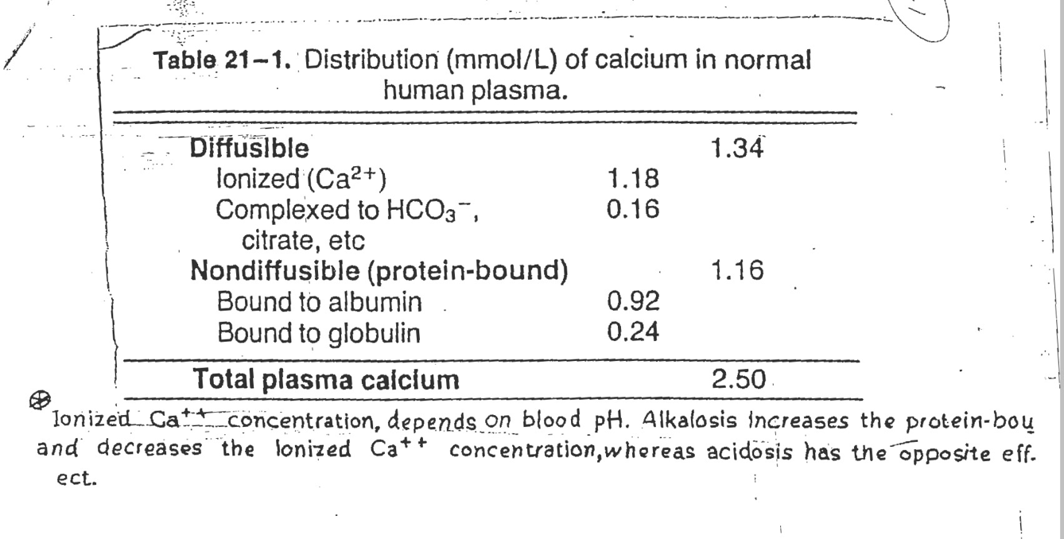
** The ionized Ca++ conc. is the indicator which PTH secretion depends on, not the protein-bound portion.

** According to the previous table, we can notice that both concentrations ( diffusible & non-diffusible) are almost equal in normal conditions.
-They become unequal in cases where :
- There’re disturbances in plasma protein levels, e.g: Hypoalbuminemia .
- There’re disturbances in blood PH : Alkalemia leads to Hypocalcaemia , while Acidemia leads to Hypercalcaemia .

Calcitonin: ( a 32-amino acid peptide)
-Secreted by thyroid parafollicular cells (C cells).
-It counteracts PTH action.
-It’s also present in the nervous tissue where it functions as neuromodulator.
-The major stimulus is high serum levels of Calcium.
-It works to decrease the calcium levels in the blood by inhibiting the osteocytic osteolysis and osteoclastic bone resorption as well as by decreasing its reabsorption from the kidneys. It’s degraded in the liver & kidneys after a half-life of 30-50 mins.
NOTES:
**Calcitonin deficiency doesn’t lead to hypercalcaemia and its hypersecretion doesn’t cause hypocalcaemia. Why? Because PTH & Vit.D can compensate for that abnormality in Ca++ levels ( they’re the dominant regulators of Calcium levels).

** Bone mass in males & females starts to differ only after puberty, meaning that it’s the same in both genders during childhood.
**9% of our body’s water is found in bones.

Summary about phosphate regulation : its levels are increased by vit.D & decreased by PTH & calcitonin.
Its physiologic functions are :
- Part of the intracellular buffer system.
- Important constituents of many macromolecules,e.g; nucleic acids, phospholipids …
- Constituent of bone ( about 85% of our body’s phosphate is in the bone).

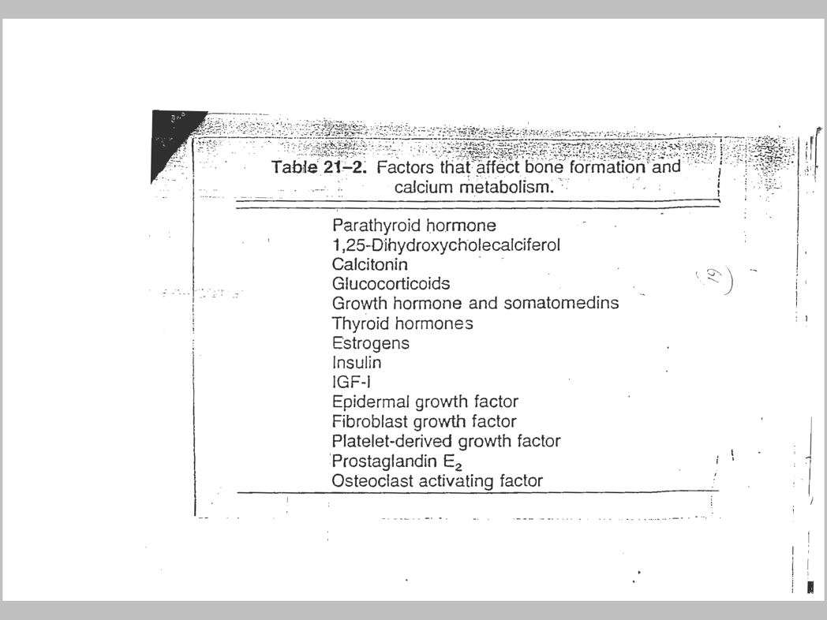
** Factors that affect Ca metabolism :

- Osteoporosis:
It’s the most common of all bone diseases, specially in the elderly.
Results from diminished organic matrix rather than abnormal bone calcification as in rickets & osteomalacia.
-The cause of the diminished bone is excess osteoclastic activity.

Causes:
Lack of physical activity, DM type 2, malnutrition, lack of vit.C, lack of estrogen(postmenopausal women), old age, Cushing syndrome & acromegaly.
Prevention :
Physical exercise, increased Ca++ intake, medications which are divided into 2 categories:
- Drugs that inhibit bone resorption .
- Drugs that induce bone formation.
** estrogen supplements Are the most widely used medications in fighting osteoporosis, they’re very effective if the female starts taking them at the onset of menopause.
Some people take calcitonin instead of estrogen, but it’s less effective & more expensive.

Pancreas :
-It’s a dual-function gland; having features of both exocrine & endocrine glands.
*The exocrine part >> secretes pancreatic fluid that contains digestive enzymes.
*The endocrine part (Islets of Langerhans) >>comprises (1-2% )of the pancreatic mass , secretes hormones.
-Pancreatic enzymes are of a great importance as they’re the only enzymes in the body that can work on carbs., proteins, and lipids together.
-Pancreatic enzymes & hormones are stimulated by : 1-Ingestion of nutrients. 2- Gastrointestinal hormones.
** Cells of the islets:
Cell Type | Approximate % of islet mass | Secretary product
Alpha | 20% | Glucagon.
Beta | 75% | Insulin & Amylin .
Delta | 3-5% | Somatostatin.
F cell ( PP cells ) | <2% | Pancreatic polypeptide.

NOTES:
- Somatostatin is a polypeptide hormone. It’s a neurohormone; neurotransmitter if produced by the hypothalamus in the brain and a hormone if produced by the pancreas.
- Ghrelin : called “The hunger hormone”, regulates the appetite, produced MAINLY by the stomach ( fundus). It indirectly stimulates insulin secretion , how ?!
Empty stomach >>Ghrelin release >> feeling hungry>> eating >> high levels of Carbs. >> insulin secretion.
- Amylin: “Islet myeloid polypeptide” . It’s co-secreted with insulin from beta cells ( it complements the action of insulin).

** pro-insulin :
-It’s the prohormone precursor of insulin
-Consists of : A chain, B chain, and C peptide [ connects A & B chains ].
-The mature insulin is formed by abstracting the C-peptide from the center of proinsulin sequence and the A & B chains are then joined by disulfide bonds.
-Secreted in small amounts and has 10% of insulin activity.
-NOTES :
* (50-60)% of the insulin is captured by the liver( not released into the circulation).However, the remaining C-peptide is released into the circulation.
* In order to assess insulin secretion in diabetic patients, we depend on C-peptide levels since it’s secreted in the same amount as insulin. Even if the patient receives insulin injections, still we can depend on C-peptide in our measurement since its level equals the endogenous insulin ONLY, so it’s not affected by any exogenous amounts of insulin.

-Insulin & glucagon are the main regulators of blood glucose levels in the body .
==> there’re other hormones that are involved in glucose homeostasis, such as: GH, cortisol, catecholamines & THs ).
These regulators are either Hypoglycemic agents( decrease the level of Glu in the blood) or Hyperglycemic agents ( increase the level of Glu in the blood).
** Insulin is the only NATURAL hypoglycemic hormone in the body.
**Glucagon is the most potent hypergycemic hormone in the body,followed by cortisol.

-Insulin receptor : belongs to the class of tyrosine kinase receptors ( transmembrane receptors), composed of 2 alpha & 2 beta subunits connected via disulfide bonds.
-mechanism of action :
Insulin or other ligands like ( IGF-1 & IGF-2) bind to alpha subunits >> structural changes lead to the activation of beta subunits which are connected to tyrosine kinase >> autophosphorylation of various tyrosine residues >> physiologic response.

** Functions of insulin :
- Activation of glucose transporters,especially GLUT-4. So, it stimulates glycogen formation.
- Plays a role in protein synthesis by stimulating a.as uptake.
- Plays a role in fat synthesis by increasing the esterification of F.As
- Growth & gene expression.
- Decreases glycogenolysis and gluconeogenesis.
- Increases K+, PO4-3, & Mg uptake into cells.
- Activates phospholipase C which produces DAG & IP3 as 2nd messengers.

Factors that increase insulin secretion | Factors that decrease insulin secretion
Increased blood glucose.  Increased blood free F.As.  Increased blood a.as .  Glucagon, GH & cortisol  Parasympathetic stimulation,e.g; Ach.  Beta Adrenergic stimulation.  Insulin resistance ( seen in obese people).  Sulfonylurea drugs.  Ghrelin.(INDIRECTLY)  GIT hormones( gastrin, cholecystokinin, secretin, gastric inhibitory peptide ). | Decreased blood glucose.  Fasting.  Somatostatin.  Alpha Adrenergic activity.  Leptin from adipose tissue.

-How does glucose stimulate insulin secretion ?
High glucose levels in the circulation >> increased Glu uptake by pancreatic beta cells through GLUT-2 >> increased intracellular Glu leads to increased ATP production >> high ATP/ADP ratio >> leading to closure of K+ channels and depolarization of the cell >> opening of Ca++ channels >> insulin secretion.

NOTE: insulin secretion stops when Glu conc. is equal to or less than 50 mg/100 ml.
The max. level of insulin secretion appears at Glu conc. of (300-400) mg/100ml.

** Long exposure of insulin decreases the num. or the affinity of its receptors (downregulation) while exposure to low amounts of insulin increases the affinity of the receptors ( upregulation).
- The num. of receptors per cell is increased in starvation..
- The num. of receptors per cell is decreased in obesity
- The affinity of receptors increases in cases of adrenal insufficiency.
- The affinity of receptors decreases in cases of excess glucocorticoids.

-Diabetes Mellitus : ( general differences)
Diabetes Mellitus type 1 | Diabetes Mellitus type 2
-Results from the pancreas not being able to produce enough insulin.  -Referred to as “Insulin-Dependent DM.”  Also called Juvenile diabetes.  -The cause is unknown. | -begins with insulin resistance( the cells aren’t responding to the insulin produced). Then as the disease progresses, a lack of insulin may develop.  -Referred to as non-insulin-dependent DM or adult-onset diabetes.  -the primary cause is excessive body weight.
** Diabetes can be associated with other conditions such as pancreateoctomy.
-After having a meal, insulin is released in 2 phases :
1) the 1st phase ( sudden increase ): in this phase the insulin blood conc. is very high as beta cells have released the stored pre-synthesized insulin.
2) The 2nd phase :a slow release of newly formed vesicles. Here we notice a sharp decline In insulin concentration.

** Some organs take glucose continuously & spontaneously ( without the need of insulin) because they’re vital organs, while others require insulin for Glu uptake.
Tissues that don’t need insulin for glucose uptake | Tissues that need insulin to facilitate glucose uptake
-Brain  -Kidney Tubules.  -Red Blood Cells.  -Intestinal Mucosa. | -Skeletal muscles. –Cardiac muscles.  -Smooth muscles. –Adipose tissue.  -Leukocytes. – Aorta  -Crystalline lens of the eye -pituitary  -Fibroblasts - A cells of the pancreas  -mammary glands.

** The normal blood glucose level( tested while fasting) for non-diabetics should be between 90 & 100 mg/dl. Fasting Glu level above 110 mg/dl is considered abnormal >> pre-diabetic or diabetic. So, the normal range is 70-100 mg/dl.
**Glucose isn’t normally excreted in the urine, but when blood glucose levels exceed the renal threshold (180 mg/dl), glucose will be excreted in the urine (Glycosuria).
-Insulin deficiency leads to many disorders in the metabolism of lipids, proteins & carbs. Which may culminate into further problems, such as : microvascular lesion, renal glomerulus insufficiency and peripheral neuropathy.

** Diabetes & obesity are closely linked.

Effects of insulin deficiency on :
- Lipid metabolism :
-The most important effect is that the enzyme Hormone Sensitive Lipase is activated causing hydrolysis of the stored triglycerides >> lots of F.As & glycerol are released into the blood.
So at insulin lack stage, the body would totally depend on the energy derived from those free F.As. But, when there is a high utilization of F.As , there’ll be production of ketone bodies ( ketogenesis) >> increased ketone bodies in the blood (ketonemia) >>leading to acidosis.
** Ketone bodies are :
Beta-hydroxybutyric acid, Acetone , and Acetoacetic acid.

-Some of the ketone bodies are excreted in the urine ( ketouria) and they bind to Na+. The problem is that the Na+ being excreted is replaced by H+ which also causes acidosis.
So, acidosis results from the production of ketone bodies and replacement of Na+ by H+

- Protein metabolism :
Lack of insulin >> no protein synthesis >> this means there’ll be increased protein catabolism >> increasing the a.as in the blood.
>>These a.as are utilized either for energy or for the production of glucose (gluconeogenesis) >> causing more hyperglycemia.
So, the degradation of proteins increases glucose in the urine >> high osmotic pressure >> severe diabetes mellitus , weakness, and urination.
-leads to Nitrogen loss in urine and increased urea.

- Carbohydrate metabolism :
If you consider a patient with 300 mg/dl Glu conc., there’ll be :
-Hyperglycemia,however, the brain isn’t affected.
-Entering to adipose tissue is affected.
-Some enzymes are activated.
-Glucose coming from the liver is more than that transferred to it.
-Glucose transferring to the muscles & other tissues is affected.
-Glycosuria, because the conc. of glucose is above the renal threshold ( 180mg/dl).
-Osmotic Diuresis : due to increased Glu conc. in the renal tubules>> water can’t be reabsorbed >> excessive secretion of water >> increased osmotic pressure.
-Depletion of electrolytes.

*** there’re four causes of coma that can occur due to complications of diabetes :
- Acidosis & dehydration.
- Hyperosmolar coma: in which insulin will be elevated to an extent that it becomes independent of PH.
- Lactic acidosis: where there’s accumulation of lactate in the blood, which may lead to diabetic ketoacidosis if the tissue became hypoxic.
- Brain edema : occurs in 1% of children with ketoacidosis.
- There’s a coma due to hypoglycemia. Coma occurs if the blood glucose is below 40 mg/dl. But actually it depends on the individual; sometimes it may reach 25 mg/dl without coma & sometimes coma can occur at blood Glu level of 40-50.

** Diabetic patients who take insulin injections are vulnerable to coma due to hypoglycemia.so, they’re advised to have sweets in their pocket.

****All those effects collectively lead to acidosis & dehydration >> Coma and may lead to death.
DIABETES MELLITUS :
DM TYPE 1 | DM TYPE 2
It’s genetic | Obesity-onset diabetes
Age of onset : usually In children(<30 yrs) | In adults > 40 yrs
Ketosis-prone diabetes | Ketosis-resistant diabetes
Body mass :Low(wasted)-Normal body mass | Obese
Plasma insulin :Low or absent | Normal to high
Plasma glucagon : high, can be suppressed | High, resistant to suppression
Plasma glucose: increased | Increased
Insulin sensitivity : normal | Reduced
Therapy : insulin | Therapy: wight loss, control their diet & exercise, or medications like insulin, sulfonylureas, metformin…(the last choice).

** Symptoms that are used to diagnose diabetes :
- Urination.
- Increased food consumption.
- Weight loss.
** Complications of diabetes:
- Renal Failure. 3- Increased risk of cancer.
- Primary coronary arterial disease. 4- Blindness.
*More than 65% of diabetics die from heart diseases.
Drugs that are used to treat diabetes :
- Insulin sensitizer with primary action on the liver.
- Insulin sensitizer with primary action on peripheral tissues.
- Insulin secretagogues : stimulate insulin secretion, they may cause exhaustion of beta cells and lack of insulin totally.
- Agents that slow the absorption of carbohydrates.

-Measures of obesity:
Body Mass Index:
*Less than 18.5 : under-weight.
*18.5-24.9 : normal .
*25-29.9 : over-weight.
*More than 30 : obesity.
-The relationship between height & weight:
**In Males : Normal Weight = height-100.
**In Females: Normal weight = height- 105.
-Measuring the waist:
In normal people waist measure must be less than half of the height( not very proper)
**This is very important because people with long waist measure are exposed to stroke more than others because the presence of fat in the abdomen captures many vitamins e.g;(vit.D).

Glucagon:
-The most potent hyperglycemic agent.
-The half-life is 20 mins.
-The main stimulator is INGESTION OF PROTEIN, although the primary action of it is the metabolism of Carbs. & lipid in the liver.

Functions | Stimulators | Inhibitors
-Glycogenolysis  -Gluconeogenesis  -Ketogenesis  -Lipolysis | Amino acids  Hypoglycemia  Acetylcholine  Norepinephrine & epinephrine. | Fatty Acids.  Somatostatin.  Insulin.

