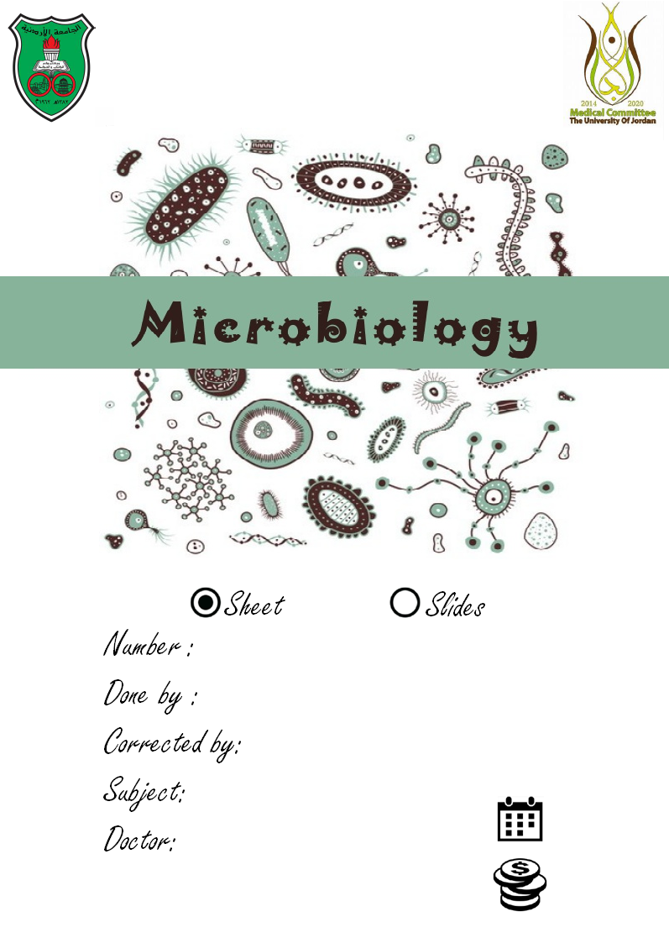

1
Mohammad Qussay Al-Sabbagh

Aya Qteish

Introduction to Microbiology

29/9/2015
Dr. Suzan Matar
……..

Introduction to microbiology :
Microbiology : (Literally mīkros, "small"; bios, "life"; and logia) is a part of biology that studies microscopic organisms, such as bacteria, viruses, archaea, fungi, algae and protozoa . here , we usually use a MICROscope to study these MICRO organisms , there are many types of microscope like light microscope , dissecting microscope , phase-contrast microscope and electron microscope .
Its sub-divided into :
- Virology : the study of viruses
- Mycology : the study of fungi
- Parasitology : is the study of parasites (worms and others )
- Bacteriology: the study of bacteria
Ok , we already know that Microbiology is the study of microorganisms ( microbes ) , what are these microorganisms ?
- Bacteria
- Fungi (فطريات)
- Algae (طحالب)
- protozoa(الأوليات)
- Parasites
Helminths (worm-like organisms), EX : Ascaris , Taenia , bilharzia , etc …
10:00
- Viruses : not considered as true microorganisms ..
These microbes can be classified according to their lifestyle into :
- Free living : these microorganisms live freely , not depending on other living organism to get their energy , so they are not harmful , we found them usually free in the nature .

- Commensals : Living in a relationship in which one organism derives food or other benefits from another organism without hurting or helping it. Commensal bacteria are part of the normal flora in the mouth , another example is Staphylococcus epidermidis that live in our skin and cause body odor .

- Pathogenic (parasites) :simply , it's any microbe that harm other organism.
NOTE : parasites is a group of microorganisms that belongs to eukarya , but sometimes we use this term to describe any pathogenic microorganism , so don’t get confused between these two different terms .

Usually , these microbes are beneficial . However , Few species cause harmful effects ( 3% of them )
Microorganisms are unicellular cell, too small to be seen with the naked eye, recognized by light microscope. Bacteria, fungi & parasites, size above > 0.1 um , only microbes that are smaller than 0.1 um and their sizes are measured in nm are viruses .h
The order of microorganisms according to their sizes:
Viruses < bacteria < unicellular fungi and unicellular protozoa (Approximately they have the same size )
- Helminth can be seen by the naked eye.
- The smallest microorganism is virus
viruses are not considered as real microorganisms . they better described as infectious agents or particles , but why ?
- Viruses sizes < 0.01um
- Composed of only DNA or RNA.
- Grow only in living cells/tissue culture.
20:00
- Their presence structures can be seen only with electron microscope
Most microbes capable of grow & existence as single organism or together with others. Widely distributed in human, animal, plants and nature.
Microbiology has many areas of specialization including Bacteriology, Mycology (fungi), Virology, Medical microbiology, clinical microbiology, diagnostic microbiology, Immunology, Food microbiology, Biotechnology (Genetic engineering ) , Microbial genetics, Industrial microbiology, Agriculture Veterinary .
Bacteria (bacteriology)
Bacteria: constitute a large domain of prokaryotic microorganisms.
So what do we mean by prokaryotic ?
prokaryote : (Literally Pro, "before" and karyon "nucleus ") is a single-celled organism that lacks a membrane bound nucleus (karyon), mitochondria, or any other membrane-bound organelle .
- The smallest bacterium is Mycoplasma ( 0.3 um )
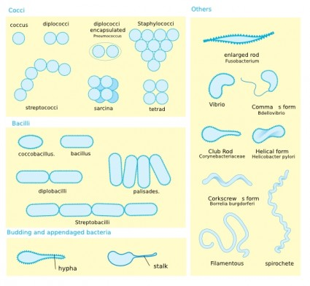
As seen in figure above , Bacteria Have a variety of shapes :
- Coccus (Plural : cocci ) : spherical
- Bacillus(Plural :bacilli ) :Rods
- Coccobacilli : in between
- Spiral forms- spirochetes
- Vibrios (ex:colira) comma shaped bacteria
Individual cells may be arranged in pairs or clusters or chains , as seen in figure above ( you should be familiar with these shapes )
We also classify these bacteria according its Growth patterns & metabolic characteristics .
- Growth patterns : does it grow slow , fast or in between ? , some of them need CO2 , O2 , N , S , some of them resist dryness , some of them need 25C to grow , others 70 , others -6 , etc ..
- Metabolic characteristics : What they need for nutrition , some of them need N , cystine , egg yolk , oval albumin , beef , etc …
Sometimes they need NOTHING to grow , they only need minerals to synthesis their own food , such as pseudomonas . it can grow only with agar and some minerals .
30:00

Bacteria Nomenclature : Genus + Species.

For example : staphylococcus aureus
genus species
We have another criteria to classify bacteria , by Gram-stain :
- For any stain you must first smear the substance to be stained (sputum, pus, etc.) onto a slide and then heat it to fix the bacteria on the slide .
- Pour on crystal violet stain (a blue dye) and wait for 35 seconds .
- Wash off with water and flood with iodine solution and wait for 35 seconds .
- Wash off with water and then "decolorize" with alcohol for 10 seconds
- Finally, counter-stain with safranin (a red dye).

When the slide is studied microscopically, cells that absorb the crystal violet and hold onto it will appear blue. These are called gram-positive organisms. However, if the crystal violet is washed off by the alcohol, these cells will absorb the safranin and appear red. These are called gram-negative organisms.

Gram-positive = BLUE
I'm positively BLUE over you!!

Gram-negative = RED
No (negative) RED commies!!

But why this happens , what's the magic in this technique ??
To answer this question we should firstly study bacterium cell wall structure , and its general structure .

when you look at bacterial cell (as seen below ) you will find some thing projecting outward . called flagella

Flagella:
Organs of motility, Composed of flagellins (polymer proteins) long filament , Length up to 20 um , cells could have one , two , even dozens of flagella :
- Single polar flagellum (monotrichous)
- Several polar flagella at one, each end of the cell or covering the entire cell surface (peritrichious)
For example : flagella cover the entire cell surface of e coli bacteria

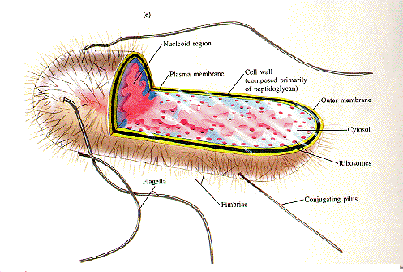

As you go deep . you will find capsule (protection) , cell wall (preserving the shape) , plasma membrane , cytoplasm , chromosomes (genetic material , usually circular, one chromosome ) , bacteria have an external genetic material called plasmid , we also have ribosomes (for protein synthesis) , and some granules .
40:00

NOTE :
- The thickness of capsule is different from one kind to another
- There are regular capsule and irregular capsule ( mucus )

NOTE : some bacteria can do cellular respiration and even photosynthesis , but without specialized organelles (Mitochondria and chloroplasts ) , and without vacuoles and any compartment .

Cell wall :
The cell wall is Composed of many peptidoglycan layers (carbohydrate-larger- / small peptide) :
(N-acetylglucosamine + N- acetylmuramic acid) + Pentapeptide.
The difference between peptidoglycan and peptide-carbohydrate mixture is that peptide and carbohydrate are covalently bonded in peptidoglycan.

Ok , now what's the difference between gram +ve cell wall and gram –ve cell wall ??
Gram +ve cell wall 80 layers
Gram -ve cell wall 3-5 layers

What's the magic there ?

Gram +ve cell wall :
- Thick cell wall composed of many layers of piptidoglycan .
- When we add crystal violet stain , the cell wall is going to absorb a huge amount of the stain .
- Then , when we add alcohol for 10 seconds to decolorize the specimen , it will not remove all the stain , because 10 seconds are not enough to remove this huge amount .
- When we add safranin stain , it will not find a place to stain , because crystal violet stain is already there ! ( the cell wall will appear Violet under L.M )
NOTE : the cell wall of gram + bacteria has Teichoic acid and Lipoteichoic acid ( Alcohol derived molecules )

Gram -ve cell wall :

They have different structure !
Underneath the capsule , it has a lipid bilayer called outer membrane , then we have a small cell wall ( 2 layers ) then we have a plasma membrane ..
- When we add crystal violet stain , the cell wall is going to absorb some of the stain .
- Then , when we add alcohol for 10 seconds to decolorize the specimen , it will remove all the stain , because 10 seconds are enough to remove this amount .
- When we add safranin stain , it will find a place to stain the cell wall .( the cell wall will appear red under L.M )

Note :
- there is no relation between pathogenicity and +ve or -ve gram ..
- there is no relation between the shape of bacteria and +ve or -ve gram
( for example : not all cocci bacteria are gram + bacteria or gram – bacteria )

THE END

