Biochemistry summary
Lecture #1 :
- Hormones are chemical substances (organic in their nature) produced by glands and are transported by the circulatory system to target distant organs.
They’re SPECIFIC, affect ALL tissues, and are produced in LOW amounts.
- Functions of hormones: 1- Maintaining our homeostasis. 2- Mediating responses to external stimuli. 3- Play roles in growth & development .Also , they regulate our physiology & behavior.
- Classes of hormones: * Endocrine hormones ( acting at distant places ). * Paracrine hormones (acting on nearby cells ). * Autocrine hormones (acting on the same cell that has secreted them ).
- We have 75 billion cells, forming 200 types of differentiated cells. Out of these 200 types , less than 50 types produce hormones .
- Factors that determine the response of a target cell to a hormone:
1) Factors that affect the concentration of the hormones at the target cell, which include
- The rate of synthesis and secretion of the hormone from its source.
- The proximity of the target cell to the hormone source (Dilution) .So, close distance between the target cell & the gland means that the concentration of the hormone would be less diluted, and vice versa.
- The Kd (dissociation constant) of the hormone-receptor complex. Kd tells us how much the affinity is between the hormone and its target cell. Low Kd value means high affinity, and vice versa.
- The rate of conversion of inactive form to the fully active form(time & amount wise).
- The rate of clearance from the plasma.

2) Factors that affect the target cell response :
- The number, relative activity, and state of occupancy.
- The metabolism( activation/inactivation) of receptors of the hormone in the target cell.
- The presence of factors within target cell necessary for the response.
- Up- or down-regulation of the receptor.
- Post-receptor desensitization of the cell >> down-regulation.
** There’re molecules within the target cell; such as co-repressors & co-activators, that might activate or inhibit the message & the effect in the target cell >> so,they control the hormone at the cellular level.
- NOTE: Receptors follow type A response.
** The concentration of hormones in the blood & ECF = 10⁻¹⁵ to 10⁻⁹ mol/L . ** Other structurally similar molecules; such as sterols, amino acids, peptides & proteins , are found in higher concentrations( 10⁻⁶ to 10⁻³ mol/L ). This means that there’s a competition between hormones and those molecules.
- The hormone-receptor interaction (binding ) : 1- should be Specific >> displaceable by agonist or antagonist. 2- should be Saturable >> all receptors should be occupied by hormones . 3- Should occur within the small amount of hormone within the ECF .
** The type of binding between the hormone & its receptor is non-covalent >> irreversible binding , so that we could have dissociation.
** Kd values for many hormones range from 10⁻⁹ to 10⁻¹¹ ( around 10⁻¹⁰) >> very small value which means that the affinity is high.
-Note: For receptors to be saturated with hormones , the hormone’s conc. Should be 20X the dissociation constant (20*Kd).
** Hormones have specific binding with receptors but a few proteins do nonspecific binding.
** Receptors can be found in the membrane, in the cytoplasm, or in the nucleus.
-Receptor Domains: All receptors have at least 2 functional domains: 1- Recognition domain (hormone-binding site ) >> to recognize the hormone. 2- coupling or signal transduction domain >> to transfer the signal.
** Coupling occurs in 2 ways:
- Changing the activity of an enzyme in the plasma membrane >> this applies to lipid-insoluble hormones like polypeptides and catecholamines.
- Directly entering the cell >> applies to lipid-soluble hormones which have cytoplasmic & nuclear receptors; such as steroids,retinoids,and thyroid hormones
- Steroid, thyroid, and retinoid hormones receptors have many binding sites: 1- Hormone-binding site(recognition domain), 2- DNA- binding site. 3-Co-regulator proteins binding site (increases or decreases the activity of the receptor) 4- Cellular trafficking proteins binding site.
** So, steroid hormones receptors have more domains compared to amino acids & polypeptide hormones receptors.
- SIGNAL AMPLIFICATION :
E.g, when a hormone is secreted from the hypothalamus, it’ll be in nano-grams, then those secreted from the pituitary will be in micrograms, and finally the hormone that reaches the target cell will be in milligrams. So, you started with one molecule and you ended up having 10⁸ molecules via amplification.
** Receptor-Effector coupling is the 1st step in amplification. - Amplification means less energy use, more action, and stronger response.
- Hormones are controlled by feedback mechanism : 1- Ultra-short loop 2- Short loop 3- Long loop
- Classification of hormones : * Based on their chemical structure : 1) Polypeptides : all pituitary & hypothalamic hormones , insulin, glucagon, growth factors ….. 2) Amino acid derivatives: Thyroid hormones & catecholamines(epinephrine , dopamine, etc …)
3) Steroids : Androgens and estrogens & adrenal cortex hormones.
* According to their mechanism of action (more realistic) : 1) Hormones that cross the cell membrane (lipid-soluble) and bind intracellular receptors. E.g, steroids, calcitriol, retinoid & thyroid hormones. ** For those hormones to be transferred through the blood, they have to be bound to transport proteins >> Long half-life and slower action. 2)Hormones that bind to cell surface receptors .They move through the blood by themselves without transport proteins and they transfer the message via a 2nd messenger.
Hormones that bind to cell surface receptors (According to second messenger): ▪
- cAMP (β adrenergic factor, glucagon, ACTH),
- cGMP (atrial natriuretic factor, Nitric oxide) ▪
- Calcium or phosphatidyl inositol (oxytocin, TRH) ▪
- Kinase or phosphatase cascade (insulin, GH)
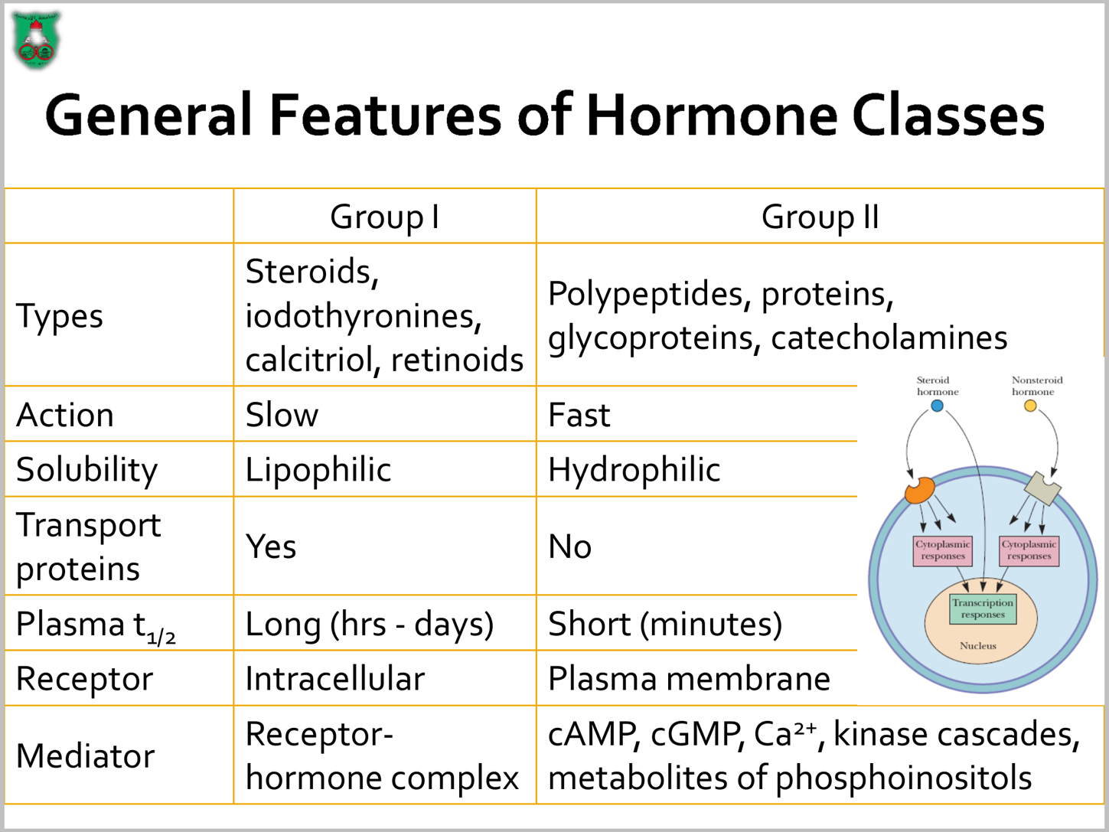

*Steroid Hormones : ( cholesterol is their origin ) 1) Sex Hormones : - Male sex hormones(Androgens) . - Female sex hormones(Estrogens) . - Pregnancy hormones(Progesterones).
2) Adrenal Cortex Hormones :
- Mineralocortocoids (Aldosternoe) - Glucocorticoids. - Adrenal Androgens (Testosterone & DHEA ) .
*Non-steroid Hormones: - Peptide and protein hormones : all pituitary and hypothalamic hormones are made of single polypeptide chain EXCEPT: TSH,FSH&LH (they’re big homodimers glycoproteins).
-Amino acid derivatives : derived from tyrosine(T3,T4, epinephrine & norepinephrine) or tryptophan (melatonin). ** Epinephrine differs from norepinephrine only by a methyl group ( epinephrine has a methyl group ) **NOTES:
-GH , LH & FSH are big hormones( glycoproteins). -TRH is the smallest peptide hormone (3 a,a s): Glutamic acid- Histidine- Proline. -ACTH structure has 2 parts; constant & variable. -ADH and oxytocin are synthesized in separate cell bodies of hypothalamic neurons and they differ at a,as # 3&8 : in oxytocin => a,a#3 : Ilu , a,a#8 : Leu while in ADH(vasopressin) => a,a#3 : Phe , a,a#8 : Arg - Insulin is a long polypeptide and is synthesized as pre-pro-hormone. >> A large precursor preproinsulin : a 23-amino acid signal sequence , 3 disulfide bonds Removal of the signal sequence gives >> Proinsulin : has the c-peptide. Removal of the C-peptide gives >> Mature insulin : A & B chains connected to each other via disulfide bonds.
** One gene may code more than one hormone , e.g: POMC gene which gives ACTH , MSH, lipoprotein and endorphin.
************************************************************************ lecture # 2:
Because more than one hormone can affect the same cell , there should be some kind of integration between those hormones, such as:
1) Permissive effect: means that binding of the 1st hormone will make it easier for the 2nd one to bind so that the response would be greater. E.g; when estrogen binds and then upregulates progesterone receptors in the uterus. Also, when thyroid hormone increases the effect of epinephrine on breakdown of triglycerides in adipocytes. 2)Integrative effect : hormones produce complementary effects on different tissues . e.g. vit.D(Calcitriol) and PTH increase ECF Calcium. 3) Synergistic effect : when the effect of the 2 hormones together is much higher than when each hormone acts alone. E.g; FSH & estrogen for normal oocyte development , FSH & testosterone together increases spermatogenesis. 4)Antagonistic effect : 2 hormones work against each other . e.g; insulin & glucagon.
- Signal Transduction : the conversion of one form of a signal to another>> cellular response. - Amplification is a must & it happens through enzyme activation or membrane channels activation . we don’t increase the conc. Of the hormone to have amplification, why ? In order to save energy. - After amplification , the message is transferred from the outside to the inside via 2nd messengers. ** signals(polar,large) should bind to receptors that are 1) intrinsic membrane proteins 2) Transmembrane ( crossing the membrane). 3) with cytoplasmic & extracellular domains..
- Second Messengers : chemically, they’re small molecules,such as cAMP,cGMP, Ca⁺⁺ etc..., also the 2nd messenger could be a kinase. They are small in number compared to the number of hormones (~ 50 hormones) and they have restricted movement. 30 different types of these hormones use cAMP as 2nd messenger.
** Termination of the signal is important to save energy and to keep the cells responsive to new signals. Failure of termination may lead to many problems, such as cancer.
- Membrane associated receptors : E.g; 7 transmembrane helix receptor (7 TM) >> it’s composed of 7 alpha helices spanning the membrane, it has an extracellular side(to bind the hormone )and an intracellular side (to transmit the message) which is rich in threonine & serine (hydroxyl-containing amino acids) so as to bind phosphate . - Rhodopsin receptors, which are found in the retina and are responsible for the visual cycle , are 7 transmembrane helix receptors.
Alpha helix is a secondary structure of globular proteins. alpha helices maintain their structure by forming hydrogen bonding >> so they can make no more H.bonds with the surroundings, thus they become hydrophobic >> can be inserted within the membrane.
- 7TM receptors are rigid due to the extensive H.bonding . All these receptors are G-protein coupled receptors. (G protein is a trimer that has 3 subunits; alpha, beta & gamma).
Biological functions mediated by 7TM : smell, taste, vision, neurotransmission, hormone secretion, chemotaxis, exocytosis, cell growth, development, and viral infection.
How does it work ?
Hormone binds to its receptor >> conformational changes in the receptor & sometimes phosphorylation of serine & threonine cytoplasmic residues >> the affinity between 7TM receptor & G-protein increases >> G-protein is activated
- G-protein is inactive( bound to GDP) most of the time , when it gets activated, exchange occurs( GDP goes away and GTP comes in, not through phosphorylation of GDP to GTP) >> alpha subunit dissociates and goes to adenylate cyclase, an enzyme found in the membrane , which converts ATP to cAMP.
When one hormone binds to one receptor >> 100 G-proteins on average can bind to that receptor >> each G-protein can induce only one adenylate cyclase , so 100 adenylate cyclase will be activated >> 100 adenylate cyclase can convert 100,000 ATP into 100,000 cAMP.( because one adenylate cyclase can convert 1000 ATP --> 1000 cAMP)
- This is how amplification occurs.

- cAMP has the same structure of AMP,however, the phosphate in cAMP forms a ring with the ribose sugar.
- The function of cAMP is to bind protein kinase A & activates it, which will in turn phosphorylate many enzymes & proteins that mediate the cellular response.
>> protein kinase A is a tetramer protein with 2 regulatory & 2 catalytic subunits. When cAMP comes and binds ( we need four cAMP molecules to bind the regulatory subunits), the catalytic subunits dissociate from the regulatory ones & phosphorylate other proteins using ATP as a substrate.
- What stops the action of cAMP is the GTPase activity found within the alpha subunit of G-protein, which hydrolyses the GTP on alpha subunit >> inactivates G-protein >> it dissociates from the adenylate cyclase >> alpha subunit goes back to re-associate with beta-gamma dimer.
**NOTE : Activation of G-protein occurs through exchange of GDP with GTP, while its inactivation happens by dephosphorylation.
- G-proteins don’t always result in alpha-subunit activation & stimulation of adenylate cyclase. Actually, they're affected by 2 factors :
1-The nature of the alpha-subunit ( nature of G-protein) that could be either stimulatory or inhibitory .
>> G-protein alpha subunit transduces many activities:
1)Gs (stimulatory) : increases adenylate cyclase activity.
2)Golf (olfactory) : increases the activity of adenylate cyclase.
3)Transducin (for vision in the retina) : increases the activity of cGMP phosphodiesterase >> so it decreases the effect of cGMP.
4)Gi ( inhibitory) : inhibits adenylate cyclase activity.
5)Go (open) : opens Ca++ channels.
6)Gq : increases the activity of phospholipase C.

2-The nature of the receptor: ( whether stimulatory or inhibitory )
For example; beta adrenergic receptors are stimulatory in their nature.So, their alpha subunit is stimulatory as well, while alpha adrenergic ones are inhibitory in their nature.
** There are 20 G-proteins that are known & the num. of receptors that are bound to them is around 100 receptors, which are called G-protein coupled receptors.
Notes:
- When G-protein gets activated, it doesn’t always result in activation of adenylate cyclase; it’s not the only target for G-protein, it can stimulate phospholipase C or it can open certain channels within the membrane. Nevertheless, its main action is adenylate cyclase stimulation.
- Alpha and gamma subunits are covalently attached by fatty acids in order to keep the G-protein attached to the membrane, but beta subunit isn’t attached to F.As.
- Adenylate cyclase is a membrane protein with 12 alpha helices and it has 2 large intracellular domains which are responsible for its catalytic activity.
- CAMP is formed when the oxygen on C#3 of the ribose of an ATP molecule attacks the 1st phosphate forming a ring , the other 2 phosphates are released as pyrophosphates.
- cAMP affects a wide range of activities, such as :
- Increasing the degradation of storage fuels.
- Increasing the secretion of acids by gastric mucosa.
- Dispersion of melanin pigment in the body.
- Decreasing the aggregation of blood platelets.
- Opening Cl- channels.
- People suffering from gastric ulcer should avoid anything that increases cAMP levels ,such as caffeine, because it will worsen their condition as it blocks phosphodiesterase, which hydrolyses cAMP.
- Phosphorylation doesn’t necessarily mean activation, sometimes it leads to inhibition, e.g; glycogen synthase.

**How to terminate the signal?
- Dissociation of the hormone from its receptor ( at the binding level ).
- Hydrolysis of the 2nd messenger cAMP by the action of phosphodiesterase (at the level of the 2nd messenger).
- Inhibition of the activated G-protein by GTPase activity that’s found in the alpha subunit ( at the level of adenylate cyclase ).
- Preventing the hormonal action if it’s still attached to its receptor by an internal brake called beta-arrestin . How ?
binding of the hormone to the 7TM receptor >> receptor kinase( inside the cell )comes & phosphorylates the receptor itself >> once it’s phosphorylated ( on serine & threonine residues) , beta-arrestin binds & arrests the action of the receptor by preventing G-protein from binding to that receptor.

Cholera : ( due to a defect in the cAMP system )
A disease characterized by severe diarrhea >> severe dehydration.
Caused by a bacteria called vibrio cholera whose toxin binds to the receptors found on the intestinal epithelial cells >>activating G-protein >> activation of adenylate cyclase >> extensive production of cAMP >> export of Cl- & Na+ outside the intestinal cells in association with water >> extensive water loss >> if not controlled, severe dehydration occurs & may lead to death!

Lecture #3 :
The other pathway : phospholipase C pathway.
Hormone binds to its receptor >> activation of G-protein >> Dissociation of alpha subunit >>it goes & binds to phospholipase C which will cleave PIP2 ( phospholipid)into DAG and IP3 by breaking the diesteric bond between C & P.
** DAG: for most of the part,it is a lipophilic molecule >> so it’ll stay within the membrane. But it can be considered as amphipathic molecule due to the presence of oxygen ( hydrophilic head ).
** IP3 is hydrophilic , it’s a ring with hydroxyl groups & 3 phosphates.>> released in the cytoplasm. Also, it’s the actual 2nd messenger because it can reach the cytoplasm

** Phospholipase C has many isoforms, but beta isoform is the only one which has the capability of binding with G-protein ( it has a G-protein interactive domain ). So, it’s the only isoform that can enter the previous cascade , while other isoforms cannot.
Also, phospholipase C has many binding domains :
1)Catalytic domain ( a site for the action to occur)
2)PH domain( for the attachment to the lipid head )
3)C2 domain ( for the attachment to phospholipid head )

It works as the following :
Hormone binds to its receptor >> activation of G-protein >> which binds the G-protein interactive domain to induce the activity of the enzyme >> conformational changes within the enzyme lead to the binding of C2 & PH domains to the membrane>> conformational changes within the catalytic domain to start the reaction:
PIP2 ==> IP3 + DAG
Now ,the fate of each product is as follows :
**DAG will stay within the membrane.
**IP3 will be directed towards Ca++ channels on the cell membrane & on the ER.
- These Ca channels are composed of 4 subunits, binding of 3 IP3 molecules at least molecules will make them active . This binding is a cooperative binding, which means that it's difficult for the 1st molecule to bind, but for the 2nd & 3rd molecules it’ll be much more easier. >> Sigmoidal shape plot.
This leads to huge influx of Ca++ from the ER to the cytoplasm.
DAG has the ability to enhance other kinases, such as protein kinase C .But in order for DAG to perform its function, it needs Ca++ , which is released from the ER by the help of IP3.
Like phospholipase C, protein kinase C has many binding domains :
1)Ca-binding domain 3)Catalytic domain. 2)C1 domain ( to bind DAG). 4)Membrane binding domain.
Along with those domains, there’s another domain,which is the pseudo-substrate domain. >> it’s an amino acid sequence that mimics the sequence of the inhibitory substrate of the active site. So, it works as a competitive inhibitor.
The difference between them is that the substrate has threonine & serine residues, while the pseudosusbstrate has Alanine which can’t be phosphorylated so it works as a cover on the active site.
Once protein kinase C binds to Ca and gets activated >> it goes to the membrane >> then C1 domain binds DAG >> pulling the pseudosubstrate domain away and expose the active site >> then the enzyme can perform its action.
Now, how to terminate its action ?
1)Removing the phosphate group which are found on the inositol ring one by one by the action of phosphatases ( removal of the 1st phosphate will make the structure inactive )
2) Addition of one phosphate forming a tetraphosphate inositol which is inactive
Then it’s metabolized by removing phosphates under one condition which is that the 1st phosphate to be removed is one from the original phosphates (1,4, or 5) , not the last one added (#3).
For those who suffer from depression & psychological diseases, lithium ions are used due to their ability of inhibiting phosphodiestrases so there’s no removal of phosphates >> inositol will stay active.
** why is Calcium the input of that process ?
- Because of the concentration difference between the ER and the cytoplasm ( the difference is 10000 folds)
- Calcium is a bulky molecule, when it binds to a protein it’ll induce conformational changes.
- It has a +ve charge, so it can bind the –vely charged and polar a.as >> tight & stable binding.

Calcium will mainly bind to Ca-binding proteins, such as Calmodulin, troponin C, and Parvalbumin.
- All of them are composed of alpha helices.
- They’re stable & rigid due to the extensive H.bonding .
- They have –vely charged regions or polar a.as so as to bind Calcium.
- Properties : they have EF hand ; 2 alpha helices; one is short & the other is long and the area in between is either a turn super-secondary structure or a loop
- But mostly loops which are coordinated to fit the Ca++ molecule as they contain –vely charged amino acids such as Glutamic & Aspartic acids and other polar a.as. So, the 2 alpha helices aren't usually connected via turns , because turns are short( only 4 amino acids) >> they can't fit the Ca++ as it’s a bulky molecule.
NOTE: The structure helix-turn-helix is usually found in DNA-binding proteins, while most of Ca-binding proteins have the helix-loop-helix structure.
**Parvalbumin :
- The first one to be discovered.
- Contains 6 domains : A, B, C, D, E,& F.

**Calmodulin :
- It’s a Calcium modulated protein, i.e it changes its shape & gets modulated upon binding to Calcium.
- Composed of 2 large globular domains on both sides which are connected via a loop.
>> Each globular domain contains 2 EF hands, and as we know each EF hand can bind to one Calcium molecule. So, Calmodulin can bind four Calcium molecules in total.
- Binding of Ca will induce conformational changes in Calmodulin >> then the Ca-calmodulin complex can activate/inactivate other proteins & kinases. One of the targets for this complex is Ca-Calmodulin dependent protein kinase.
What are the conformational changes ?
1)A long alpha helix is formed between the 2 globular domains (not found before Ca binding).
2)Exposing some hydrophobic amino acids to the surface so that Calmodulin can bind to other proteins through hydrophobic interactions.

NOTE: The importance of Ca-Calmodulin complex resides in its ability to bind to Calcium ATPase pump in order to return the Calcium back to its origin,and consequently reducing its conc. within the cell. Why is that? Because after the release of Ca from the ER , the conc. of Ca in the cytoplasm increases and in order to maintain the potency of Ca, it has to be brought back towards its origin(ER) so that we can have another effective Calcium influx when needed.
**Calcium transporters & ATPase pumps consume a a lot of energy as we are transporting Ca against the conc. gradient. These transporters are found in huge amount (80% of membrane proteins are Ca transporters).
**ONE ATP molecule is needed to transport TWO CALCIUM molecules to the ER.
** If there was a depletion in ATP >> Ca ions can't be transported back to their origin >> muscle contractions without relaxation >> tetany will occur and after death cause rigor mortis.

The other kind of receptors that hormones can bind to is Receptor Tyrosine Kinase
-This receptor is responsible for phosphorylation & it has Tyrosines involved in this process.
-Consists of either : One polypeptide chain( one monomer with cytoplasmic and, extracellular domains &alpha helix), or dimers connected together by disulfide bridges ( like insulin receptors) or monomeric with disulfide bridges making super secondary structures.

- The monomeric receptor mechanism:
Example : class 1 & 3 receptors, such as : EGF receptors, FGF receptors, and endothelial GF receptors. So, most hormones that bind to those receptors are growth hormones , platelet derived factors as well as epidermal growth factors.
Mechanism of action :
The hormone binds one monomer >> induces conformational changes >> result in dimer formation >> once the dimer is formed, the receptor gets activated >> autophosphorylation process of the receptor itself will take place >> once the receptor is autophosphorylated, it becomes fully active.
So, dimerization alone isn't sufficient to induce the activity of receptors, it should be followed by phosphorylation.
** Proteins that can be phosphorylated by the previous mechanism:
1-Phospholipase C.
2-Protein phosphatase 1, which is linked to insulin metabolism (once insulin is bound to this protein, glycogen synthesis will be enhanced).

*** GROWTH HORMONE:
- A 200-amino acid hormone.
- Its receptor is almost 3 times larger ( 600 a.as) than the hormone itself.
- Its receptor has 3 domains: extracellular domain, intracellular domain( contains tyrosine residues), and a domain within the membrane.
- The pathway : when the receptor is monomeric it’s inactive >> when GH binds to the receptor, it becomes active >> induction of dimerization >> autophosphorylation >> the receptor is now fully active.
Now, how can that phosphorylated (fully active)receptor phosphorylate other proteins ?
Through an enzyme known as JANUS kinase (JAK) which has 2 parts; one interacts with the membrane(ERM domain) & the other (SH2 domain)interacts with the receptor tyrosine kinase. JAK can bind the tyrosine residues of the receptor ONLY when they're phosphorylated.
So , dimerization & autophosphorylation of receptors bring two JAKs together and each phosphorylates key residues on the other (cross-phosphorylation) >> the activated JAK 2 can phosphorylate other substrates,such as : STAT which will increase the transcription of mRNA from certain genes, how?
STATs have tyrosine residues, once they're phosphorylated near the carboxyl terminals , the phosphorylated tyrosine binds to SH2 domain of another STAT molecule (dimerization)>> the dimer binds to specific DNA sites >> transcription occurs.

NOTES :
-STAT stands for Signal Transducer Activator of Transcription.
-If JAK2 remains active, it’ll lead to cancer.
-Hormones that use tyrosine kinase receptors are GHs & EGFs.
*** Insulin :
-It uses tyrosine kinase receptors, but the difference is that its receptors are dimeric.
-Each monomer consists of alpha & beta subunits which are bound through disulfide bridges. >> Tetramer (2α; 2β), dimer (2αβ pairs)
Mechanism of action: insulin binds to alpha subunit >> this binding induces conformational changes within the beta subunit >> autophosphorylation >> the phosphorylated Tyrosines activate other proteins & enzymes >> physiologic response.

- RAS :
-A member of small G-protein family but it’s monomeric ,whereas G-protein is trimeric(has 3 subunits). It’s one of the downstream proteins of the tyrosine kinase pathway.
-When bound to GDP it’s inactive, while when it's bound to GTP it’s active.
-It has a GTPase activity.
- Many similarities in structure and mechanism with Gα.
- Include several groups or subfamilies. It has a major role in growth, differentiation, cellular transport, motility etc…

- Eicosanoids :
-lipidic structures that are composed of 20 carbon units.
-Unlike hormones, they work in autocrine & paracrine patterns.
-They have several classes which are derived from arachidonic acid.
-Arachidonic acid gives eicosanoids subclasses : Prostaglandins, thromboxanes, and leukotrienes .

Eicosanoids Structure:
Arachidonic Acid :
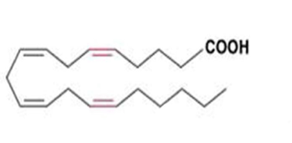
20 carbons, 4 double bonds, no ring.
Thromboxanes:
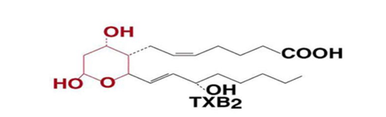
20 carbons, 2 double bonds, six-membered ring.
Prostaglandins:
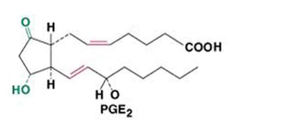
20 carbons, 2 double bonds, five-membered ring.

Leukotrienes:
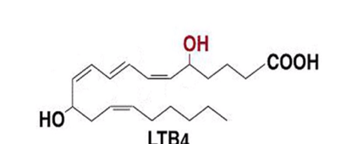
20 carbons, at least 3 conjugated double bonds, no ring.
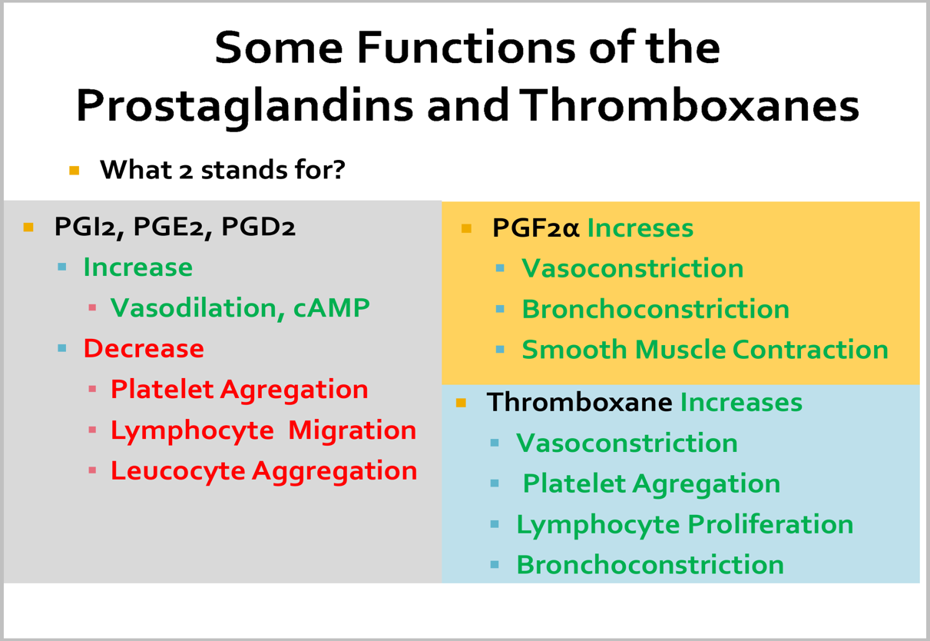

** Arachidonic Acid isn't an essential molecule as we can get it from lienolic acid through elongation & saturation. It’s located within the structure of the membrane. So, for Arachidonic acid to get out of the membrane, it needs an enzyme which is phospholipase A2 ( works on C#2 of the Arachidonic acid).
Eicosanoids can be synthesized from other polyunsaturated fatty acids:
Fatty acids of 20 carbons with: ▪
- 3 double bonds like Eicosatrienoic acid (omega-6)
>> 1double bond, PGE1 (3 → 1) ▪
- 4 double bonds as Eicosatetraenoic acid ( arachidonic acid)
>> 2 double bonds, PGE2, PGF2, TXB2 (4 → 2) ▪
- 5 double bonds (Eicosapentaneoic acid) : (omega-3)
>> 3 double bonds, PGE3, TXB3 (5 → 3) ○
** note : by every step, you're removing 2 double bonds and saturating them to single bonds. So, a compound with 3 =bonds will be converted to a molecule with 1=bond.
Which is more healthy? Less MI ▪
Omega-3: TxB3 → inhibits platelet aggregation. Can be obtained from sea-food.
>> more healthy as it prevents clotting & myocardial infarction.
Omega-6: TxB2 → stimulates platelet aggregation >> unhealthy.
THE END
Shout-out to A.K ✌

