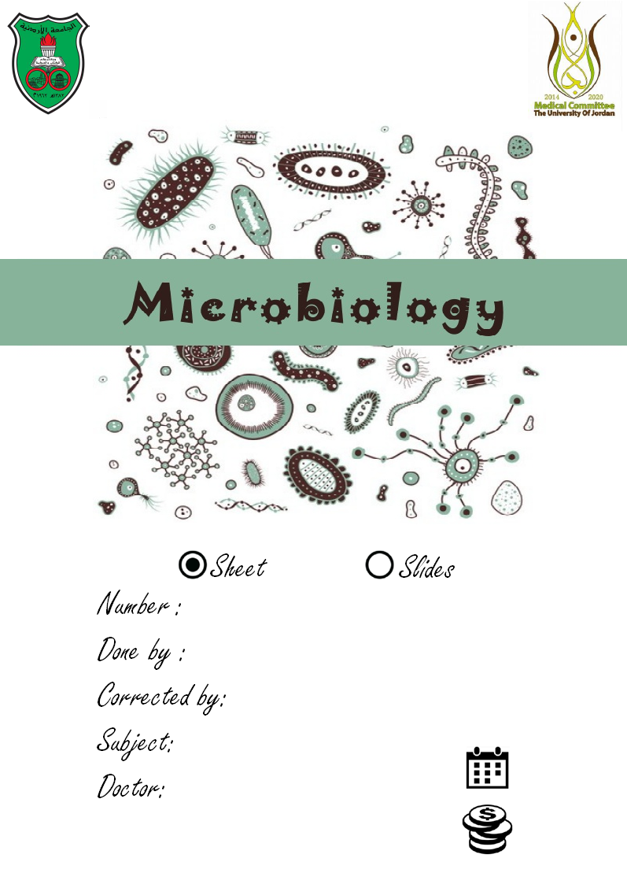

3

Tala ashour

Wala 7ada :p
Introduction to bacteria 2

6/10/2015
……..
Dr. Asem + Dr. Suzan
- Last lecture we discussed bacterial structure, classification, and other factors.

Growth factors and nutrition :

Like any other organism, bacteria need certain substances to survive, it needs appropriate temperature, PH, O, carbon, nitrogen.
- why do we need sources of carbon?
A: because all organic compounds have carbon in their skeleton backbone.
- why do we need nitrogen?
A: to build essential proteins and nucleic acids.
Bacteria also need inorganic compounds (salts, ions), they also need vitamins

- Bacteria are classified according to how it burns oxygen, into three types:
1-Obligate aerobes
2-Obligate anaerobes
3-Facultative anaerobes

obligate aerobes :
- it must have oxygen for energy, it can't live without the presence of oxygen . But Why?
A: Because it needs oxygen as a final electron acceptor (in electron transport chain) in cellular respiration to build up ATP.
- Notice that the source of energy in the previous process is glucose, which is oxidized by oxygen .
- E.g: mycobacterium tuberculosis (السل), pseudomonas origozum (skin infections)
Oxygen is a toxic material .. specially if there is radical oxygen with active electron so it might produce damage to cell membrane and might inactivate enzymes which are necessary for growth of bacteria and for the transfer of nutrients. Why can obligate aerobes bacteria grow in the presence of oxygen?
A: because they have enzymes that can break any oxygen byproducts (neutralize them) Examples are :
1- peroxidases which convert H2O2 into water and NAD.
2-Catalases, it breaks down H2O2 into water and oxygen.
3- Superoxidase dismutase ,covert oxygen free radicals into H2O2*H2O2 is very dangerous that's why we have both catalase and peroxidases to break it down.
these processes are carried on in the plasma membrane ( it is very similar to mitochondrial membrane) in the mesosomes, we have electron transport chain and enzyme needed.
- Some bacteria need oxygen in small amounts, these are called (microaerophilics) like Neisseria (causes many kinds of diseases like sexual transmitted disease) .

When these are cultured in the lab, we incubate it at 37 , with decreased amount of oxygen to be able to grow (this is just for your knowledge :) )

Facultative anaerobes:
- The majority of these kinds of bacteria is present throughout the body mostly in the intestines,these bacteria can grow both in presence of oxygen and absence of oxygen. If there is oxygen it produces ATP through cellular respiration, if there is no oxygen it produces ATP through fermentation(according to the environment :D)

Obligate anaerobes:
- it’s almost similar to obligate aerobes, but the final electron acceptor is not the oxygen(it could be sulfur or nitrogen) (instead of producing H2O it gives H2S)
We do have some of these bacteria in the mouth (especially under the gum)
Notice that for the obligate anaerobes, oxygen can be very poisonous.(why?? Because they don't have enzymes to break down H2O2) (10)

- how to identify what kind of bacteria (according to the use of O) we have??
By a very simple experiment ^_^ , shown below :
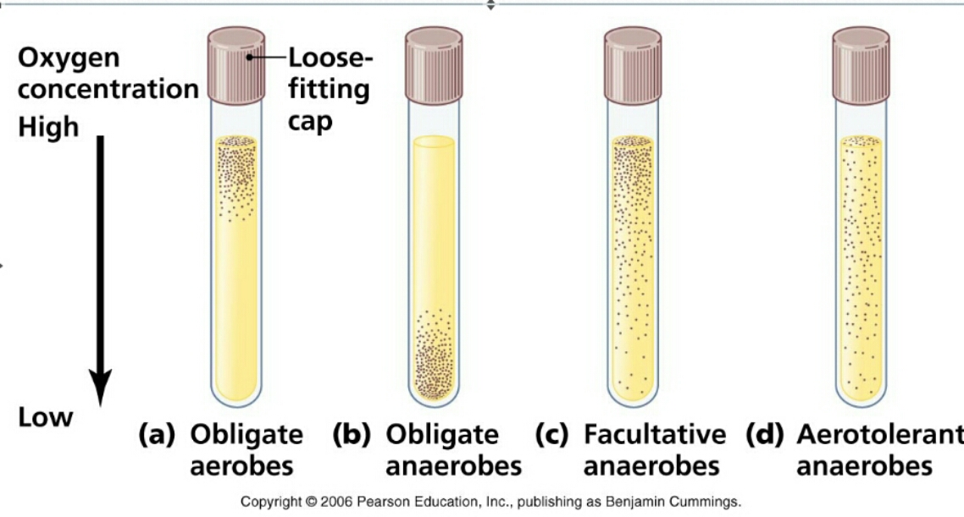
A)bacteria are all gathered in the top (closer to oxygen source) ، Obligate aerobes
B) far from the surface ، Obligate anaerobes
C)throughout the tube, but more on surface ، Facultative anaerobes
D)distributed evenly throughout the tube. ، areotolernt anaerobes (Subclass of Facultative anaerobes )

Now let's classify bacteria according to the organic compounds they break down (source of energy)
1)Heterotrophs: : type of bacteria which should be supplied with complex organic compounds (sugars ,proteins , source of carbohydrate …etc ) , most human pathogens , these cant build organic molecules (and therefor energy ) from CO2
2)Autotrophs: Fix CO2 to make their own food source , can use nitrogen and often they require for growth the source of energy other than oxygen (inorganic compounds) , not pathogenic
A)photoautotrophs : The source of energy for photoautotrophic is light energy in oxidation- reduction reaction light
B)Chemoautotrophs : are pathogenic bacteria, that uses complex compounds ( like sulfur and nitrogen fixing bacteria ) to build energy, it can't use the light in the process

- Saprophytic bacteria: non-pathogenic bacteria found in the nature , take their energy throw fermentation of sugars , the end product of fermentation are : lactic acid , alcohol , etc ..
Found in the nature specially in vegetation environment, soil .. Keep in your mind that saprophytic isn't autotrophic, it is similar to facultative, under certain condition it may reach our body and produce infection but they are not obligate, like commensal bacteria which is adaptive to our body where saprophytic is adaptive to environment but might contaminate

Culture media
When incubating bacteria, the culture media we use should be provided with contain carbohydrates and proteins at least. In addition it may contain blood (from human & animals) , minerals ( sodium chloride , Mg, K ..), water (very important)
PH is very important; different types of bacteria grow under different PH conditions.
and Temperature also: there are various types of bacteria grow over earth with wide range of temperature .
We have two kinds of culturing media:
1-solid(agar) it appears as colonies each colony was only single bacteria, by binary fission it became many.
Why is it important?
A)To recognize if there's growth
B)To know the morphological structures of the colonies.
2- liquid (broth)
It's usually water, includes certain neutrints,normally it's clear, transparent
it appears disperse.
- Within 20 hours we can notice turbidity in broth, whereas we notice colonies in solid medium.
The culture media can be :
1-general culture media: allow different kind of bacteria to grow, gram +v and gram –ve,(eg: nutrient agar, blood agar, chocolate agar)
- nutrient agar: contains different kinds of nutrients
- blood agar: contains blood
- Chocolate agar: (don’t contain chocolate, not mars or galaxy :p) it contains heated blood, we use it when the bacteria need compounds found inside red blood cells.

2- selective/ differential : sometimes in the lab you get samples with many kinds of bacteria,(like urine, other things that are opened to outer environment, it contains pathogenic bacteria and non pathogenic “normal flora” ).
If we use the general agar all kinds of bacteria will grow, and we won't be able to differentiate which one is the pathogenic one :/
Not only that! Non pathogenic bacteria grow faster then pathogenic ones, so we will find it in the agar covered with non pathogenic >.<
Selective media: it has material they will inhibit the growth of one kind of bacteria (in our example the normal flora because we want to identify only pathogenic) and increase the growth of pathogenic bacteria:) example is MacConkey agar (selecting gram –ve in urine samples, which cause UTI “urinary tract infections “
Differential media: we have two bacteria which are very similar to each other (staff oreus ، staff epidedimis “the same genera”)we need these plates to differentiate between bacteria, usually these people plates are supplemented with sugars,staff.oreus can do fermentation for example while epiderdimis can’t. So we have PH indicator, when the fermentation occurs the PH will decrease (production of lactate acid)and change the color.
Sometimes same plate can be selective and differential : MacConkey, selects gram –ve, and we have lactose sugar, and PH indicator, some bacteria will ferment lactose and some will burn it, those which ferment lactose will appear pink, and if they don't ferment lactose will appear transparent.
3-other selective media:
SS Agar (for salmonella and shigella)(20)
According to the PH the bacteria can be classified to:
1-acidophilic
2-neutrophilic
3-alkaliphilic
- the pathogenic bacteria can be any of them according to the PH of the tissue they infect, in intestines (basophils), stomach (acidophils) ,blood (neutrophils) ، But the majority are neutrophils

Acidophils: we have an acidophil bacteria called lactobacilli bacteria in the in vagina of ladies, these contribute for a healthy vagaina,and prevent infection and adherence of infectious bacteria , most ladies in 40-50 have high acidophils in form of lacto bacilli .
We also have it in oral cavity, important to produce certain type of endproduct like lactic acid which also inhibit the attachment of certain infectious organisms
Lacto bacilli is important to have biological equi-relations: to keep pathogens in reduced numbers and protect the mucosa of the oral and vagainal cavity.

Alkalophil bacteria: grow at high PH, like finbrocoliri ,

bacteria classified according to the temperature:
1-mesophilic “the human pathogenic bacteria “and most facultative anaerobes
2- psychrophilic : which grow at temperature less than 10 c , found in our refrigerator associated with food.
3 thermophilic : optimal temperature is 60 or above ,found only in hot water and often as non-pathogenic bacteria. Important to neutralizing of sulfur compounds

We said in the previous lecture that , bacteria will divide by a process called “binary fission “
generation time: time needed for one bacterial cell to become two daughter cells.
For M tuberculosis we need six weeks to have a colony.(that's why it's difficult to diagnose it :( )
For bacteria that need 20 mins we can grow it through the night to have colonies.

bacterial growth curve:
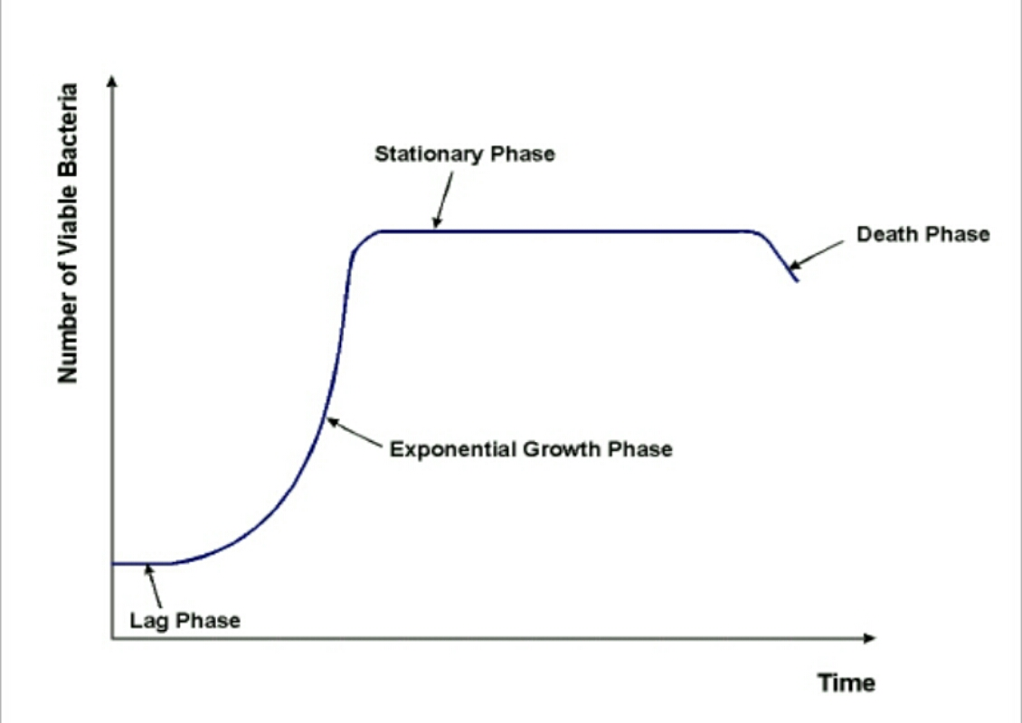

We have four stages of growth for any type of bacteria whether in fluid or solid medium but not in continuous culture , in close culture Difference between continuous and close culture as an example industry they produce end products of bacteria and fungi using continuous culture.
You control flow of oxygen , minerals , nutrients , control the toxic product .
Continuous culture is more expensive and more difficult to control whereas growth culture we have a petri dish:
You place few number of cells from other cultures or from our clinical sample such as blood, urine...etc.
21 drop about 0.01 ml We place on the surface of medium on the top , and we use pathological loop in order to have a streaking methods to dilute this fluid on the surface of the medium in 3 directions, in order to recognize at the end we have called a single colony , at the begging we have growth, heavy continuous growth ,less growth and at the end we are using best 3 streaking method; at the end we have single colony which can we utilize it for gram stain , important to be used for biochemical reactions. We can't use mixed culture , because we will have mixed end products , so culture formed for any type of organism in order to be studied and to identify, we must use pure culture originated from one single cell not from two cell or more, if from two cells we might have the same culture but we have to recognize that there is a difference between the growth of one colony and another.
Streaking method allow us to know if our clinical samples contain one single organism, two or more .. example : from skin or from urine or from blood.
If we have urine culture with two or three organism often we consider this as contamination , we don't have true type of organism which is the causative agent a certain something due to collection of species not under recommended conditions.
Go back to curve :
There are four phases we have a culture tube usually in fluid medium free of any type of bacterial cells or other viruses … etc
We place the tube and we place from our start culture which is the plate as you have seen one single colony
We take one single colony and place with the pathological loop in this tube then we Start to observe the growth
How to know the growth ?
After one hour we take 0.1 mm and we look by place on the culture of medium to see the number of cells that come out of it 1000, 2000
You see different growth and plating of organisms, at the beginning we have a huge number of cells , in the second plate we have after 1 to10 D , then there are less cells 1-1000 more less and so on .
At the end (one t 100,000) or( 1 to 10^6 ) we might recognize only few cells . Maximum we must have on the surface of plate 100 colony
In order to calculate later dilution factors which is 2 , 3 , 4 ,5 ….etc
- At the end we have this numbers of organisms and this in fact can be translated later as you see later in what we called :

1-lag phase: which is adaptation phase where cells of bacteria begin to become biological active , to be adaptive to environment , PH , temperature

2-logarithmic phase (logarithmic duplications in each cell in thousands)
and after a few hours it depends on the types of the culture medium and types of bacteria we have what we call

3- Stationary phase : bacteria has slow growth because already huge numbers of cells have utilized available nutrients in the medium , there is no enough nutrients in growth system of medium to continue in continuous culture duplicating.

In this phase : number of new cells is equal to number of dead cells

Stop in growth and later on due to presence of large number of cells in close culture medium we reach the last phase death phase due to activation of autolytic enzymes , majority of bacteria are broken down into small particles

At the end instead of 1 billion bacteria cells we have 1 million for example.. If we stay waiting another few hours we might have all bacteria in the culture medium killed.

- Summary :
How to measure the growth??
We need to recognize the actual living cells, which are replicating in the culture media or during infection.
- Indirect methods : through turbidity ,metabolic assays, dry weight
- diluting method:
1-you take a sample of the broth
2- you dilute it
3 you take inoculum and implant the bacteria
4- you count the number of bacteria
5 -you multiply it by the dilution factor
If you have normal range>> this means that the bacteria is growing normally
If you have decreased number >>there is something killing the bacteria
If you have increased number >>>you have grown factors.

THE END

