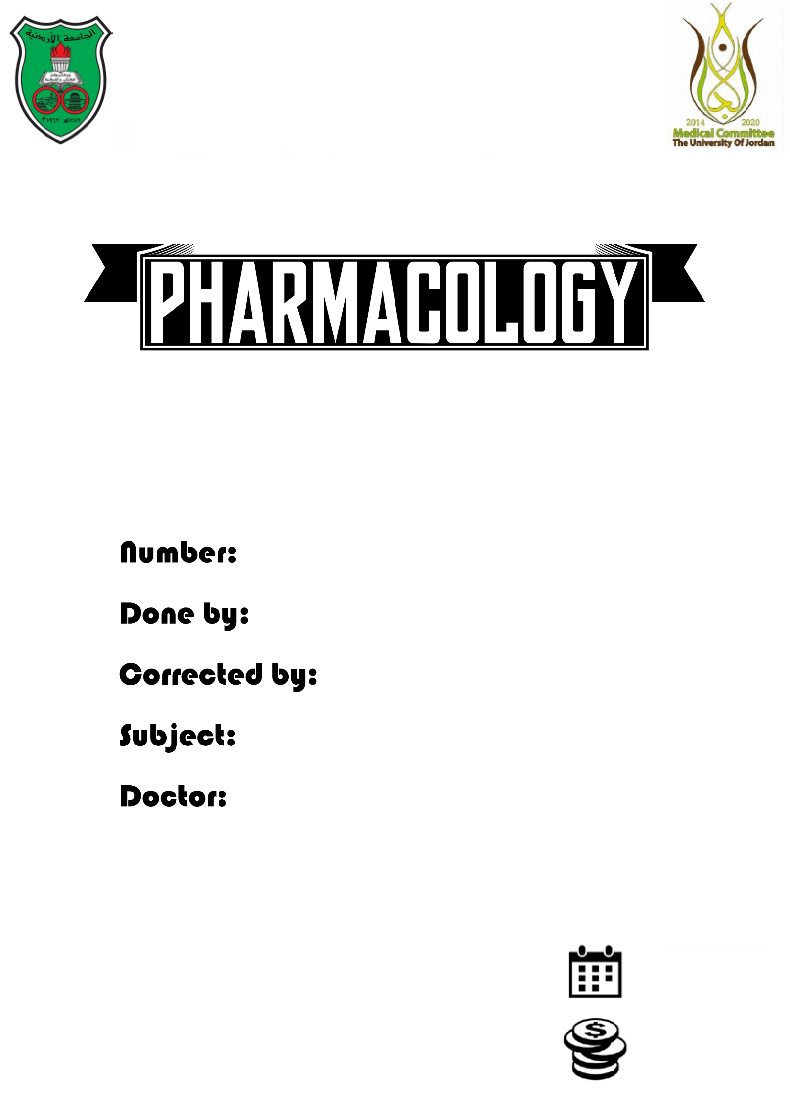

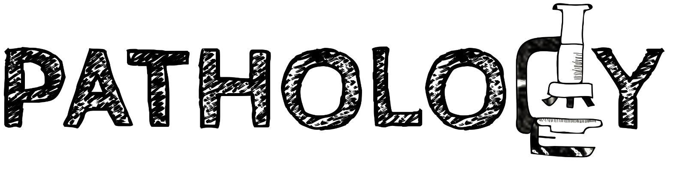

Slides
Sheets

2

Huda Akkad
Yousef Al-As3d
Cell injury, death and adaptations
Dr.Mazen

00/00/0000

Homeostasis:
Homeostasis: Steady state for any system, can be applied to molecular level, cellular level, organismal level.
Homeostasis is equilibrium your cells maintain them self within narrow range of oxygen, nutrients, etc.. that permits life to continue. (The same as “seso” when it goes one way your body push back in another way).
- General principle of homeostasis if we talk about biological system in human being that if you get hot you take off your clothes ,turn on air conditioning but if they aren’t available your body start to sweat then sweat vaporize so you cools down so you get cold . The opposite if you get cold you put clothes on your body, turn on the heat, but if they are not available your body will shiver to generate heat. (From this example we have to know that as we are active as human also our cells are active trying to maintain them self).
Cells are active participation in their environment they work in a narrow range, they also control some of the range, there's things that they can control and others which they can't control.
- Example: Cells can't control the amount of oxygen the cells receive (either the cell get the oxygen from the blood supply or it doesn’t), cells can do something more economical when using that oxygen (the can control the efficiency of using oxygen) either by not using as much energy or using a lot of oxygen when there is oxygen deficiency.
10:00

- Cell adaptation:
The general principle of homeostasis in cell adaptation that your cells either they are working normally or they have to adapt to keep working on.
- Adaptation by definition is a reversible cellular process. if your normal cell exposure to stress they well adapt by increase their size, number, function, phenotype or metabolism, but sometimes it’s unable to adapt either because the stress was too strong or too long or the cell has ran out of the ways to adapt and so cell injury occurs.
There is two type of cell injury the first is reversible cell injury when the stress or injury stimulus is mild or transient (for short time –limited) here the cell can recover to a normal cell, but if the stress is severe and prolonged it’s irreversible injury and the cell will die one of the two types of death (necrosis or apoptosis).

Cellular adaptation are divided into physiologic and pathologic. So sometimes cell have to adapt to physiological conditions and sometimes to pathological conditions.
- Example of adaptation in the heart (hypertrophy: it’s increase in size), you heart provide its own nutrients and its own oxygen and is pumping blood to the body and itself also so your heart need to keep pumping in order to survive, so what happens if you block the outlet of the heart?
The heart have to pump harder to overcome that blockage, such as when one of the valves is narrowed or the patient has a hypertension (increased blood pressure) which means that there is back pressure on the heart which means that the heart must pump faster and stronger to maintain the same amount of the blood, oxygen and nutrients. So the heart muscle will get thicker and the heart cavity will get smaller so because of that the heart have to contract stronger and more frequently, at some point the heart is no longer going to be able to adapt so can’t provide enough oxygen to the body and even to itself (the heart adapted initially then it failed) so injury occurs either reversibly or irreversibly depending on how severe the stimulus was.

How does the heart adapt? it’s adapt by increasing protein synthesis to increase myofibrils, because to make the muscle thicker you have to increase the myofibrils and some time there is a myofibrils switch from adult myofibrils to fetal myofibrils, this happens to conserve oxygen because fetal myofibrils use less oxygen .
If the injury happens quick or not gradually (faster than the heart can handle) so this will go directly to irreversible injury.

- There are four major cellular adapter responses :
1. Hypertrophy
2. Hyperplasia
3. Atrophy
4. Metaplasia (such as cells in the esophagus when the cell change from stratified squamous to cuboidal or columnar).

1- Hypertrophy:
DON’T mix between cellular hypertrophy (in cellular adapter response) and organ hypertrophy. Cellular hypertrophy means increase in cell size only but organ hypertrophy means the organ gets bigger.
The organ hypertrophy has two types, pure or mixed hypertrophy. Pure hypertrophy: increase in organ’s cells size only. Mixed hypertrophy: increase in size and number of the cells. But when we take about cellular hypertrophy the cells can only get bigger.
Hypertrophy happens in tissues that has a limited proliferative ability such as heart.
Note: Heart has stem cells, and it can proliferate under certain conditions. Example: Patients that have heart failure and can't wait for heart transplant they use left ventricular assist device that pump the blood to the body and so the heart can have a rest from pumping until they can have the heart transplant. Surprisingly, after using this device they no longer need heart transplanting and they can take off the device because the heart has regenerated itself while resting. And here the limited profanation ability appears.
In hypertrophy cells become bigger because they will have more proteins and organelles.
- Example of pure physiologic hypertrophy: skeletal muscle (when you become more weight or when you walk more the skeletal muscle become bigger).
- Mixed physiologic hypertrophy (Number and size): increasing of the uterus size during pregnancy.

2- Hyperplasia: it means increasing in the cell numbers, in the cells that has the proliferation ability such as liver.
- Lots of tissue has proliferation ability such as epithelium tissue.
This increase in cell number is typically results from hormones induced (Such as uterus during pregnancy. Also if you cut a part from the liver it has some factors that induce the liver to proliferate and regenerate itself).
Cellular adapter response by definition is reversible, so if you take away the growth factors or the hormones or there was growth inhibitors, cells will stop proliferating (While cancer won't stop even in those conditions).

- There are two types of physiologic hyperplasia :
1. The proliferation in the breast during pregnancy and puberty in the glandular epithelium.
2. Compensatory hyperplasia, in which residual tissue grows after removal or loss of part of an organ.

- Pathologic hyperplasia: after a normal menstrual period there is a burst of uterine epithelial proliferation that is normally tightly regulated by stimulation through pituitary hormones and ovarian estrogen and by inhibition through progesterone. However, a disturbed balance between estrogen and progesterone causes endometrial hyperplasia, which is a common cause of abnormal menstrual bleeding.
The problem with hyperplasia is that every time you replicate your DNA there are chances that things go wrong so hyperplasia can be a factor of cancer.

3- Atrophy: the cell retreating to a new equilibrium so it can survive. And because it is reversible response cell won’t die but it retreat by getting smaller by producing less protein, and it starts using proteins that is not needed at the time as building blocks for more important things or for energy.
- One of the ways of atrophy consist of a combination of increased protein using and degradation, and decreased protein synthesis so proteins don’t regenerate in the cells.
Protein synthesis decrease because of reduce metabolic activity.
- Another way for atrophy is actively degradation of cellular proteins (because some proteins has long half life, so this is faster). This occurs mainly by the ubiquitin-proteasome pathway, ubiquitin is a molecule that attach to a small protein that target on another protein, and when you create a ubiquitin chain with a specific shape it will tell the cell that this protein is no longer acquired the it will be sent to the proteasome which is a molecular machine that chop off other proteins.
Ubiquitin is not only used for degradation it can also be used to site signalling molecule to send protein from one side of the cell to the other side but that is not common.
30:00
In many situations, atrophy is also accompanied by increased autophagy of not needed organelles, which results in increased number of autophagic vacuoles, which are fused with lysosome, and then digested.
What cause atrophy? Disuse (Not using an organ).
Examples:
1- Not using your muscle (as you broke an arm bone you can’t move your hand) after you remove your cast the arm will be thinner than the other one because you didn’t use your muscle.
2- Another example loss of innervation.
3- Inadequate nutrition.
4- Reduction of hormones (endocrine stimulation). Like atrophy of endometrium in menopause.
5- Aging.
6- Diminished blood supply.
Although some of these stimuli are physiologic (the loss of hormone stimulation in menopause).

4- Metaplasia:
We talked about it in the previous lecture. It’s the changing from one cell type to another one. For example, the smoking person respiratory epithelium change from columnar ciliated with goblet cells to squamous without goblet cells, so it become functional disadvantage and this is epithelial metaplasia.
The metaplastic squamous epithelium has survival advantages, so by smoking important protective mechanisms are lost. Such as trapping bad materials and getting rid of it by mucus secretion and ciliary clearance of particulate matter.
In fact, squamous metaplasia of the respiratory epithelium often coexists with lung.
Metaplasia is also a factor of cancer because the cells are not in a place where they should be.
Cancers composed of malignant squamous cells.
It is thought that cigarette smoking initially causes squamous metaplasia, and cancers arise later in some of these metaplastic regions.
There is another type of metaplasia which is mesenchymal metaplasia. Epithelial metaplasia may be physiological or pathological but the mesenchymal is always pathological.

Cell injury and death:
There is two types of cell injury and death:
1- Necrosis.
2- Apoptosis.
The major difference between necrosis and apoptosis : necrosis is messy in necrosis means that the cell has opened allows the cellular contents to leak while apoptosis is programing itself to die (the death of the cell that has fallen away that the mean of apoptosis in Greek) but the cell still surrounded by membranes so there is no inflammatory reaction but in necrosis the cell membrane will breakdown and the intracellular material leak to the extracellular so there will be an inflammatory reaction because your white blood cell are concern where are these protein and unknown materials came from .
So the difference is that the necrosis is very messy but the apoptosis very organised. The necrosis cause inflammatory reaction while apoptosis don’t.
Under the microscope the two thing that will tell you that the cell goes from reversible to irreversible cell damage are major mitochondrial changes and irreversible membrane function.
In reversible cell damage you will see some swelling some abnormal myelin figure and phospholipid deposition, the reason of the swelling is the ion pumps will stop because normally your cell being active participant will exchange solute between outside and inside and keep a gradients of certain solute high in the outside and low inside if this pump stop working the solute start to go inside so you will see a swelling. But in the apoptosis the cell will shrink.
40:00

Types of necrosis:
1- Coagulative necrosis.
2- Liquefactive necrosis.
3- Gangrenous necrosis.
4- Caseous necrosis.

- Let’s talk about coagulative necrosis. This happens in all solid organs except the brain, in the brain liquefactive necrosis can happen.

- The liquefactive necrosis is aseptic in the brain but if it happens somewhere else it will cause infection, abscess and pus and here it is septic (pus means dead bacteria and white blood cells).

- Gangrenous necrosis: it’s coagulative necrosis, it still common in clinical practice that why it’s mentioned, it happens by the loss of blood supply.
Example of where the gangrene occurs:
It occurs in a diabetic patient. Also it can occurs in healthy persons because of the extreme cold (frostbite –عضة الثلج) because it constricts your blood supply in some places like a part of your nose, ear and toe (which already has little blood supply).

- Caseous necrosis: (caseous means cheese in Spanish) it’s cheese like necrosis.

- Fat necrosis: there is two type of fat necrosis the first one is Enzymatic fat necrosis and the second is Traumatic fat necrosis (the book didn’t mention the second type).

- Enzymatic fat necrosis: your exocrine enzyme from the pancreas has leak into your body, inside the peritoneum you have fat they going to release fatty acid and it combine with calcium to produce fat saponification.

- Traumatic fat necrosis: like in breast trauma that might result in fat necrosis that can be calcified and misdiagnosed clinically as malignant tumor. Because of that it is highly important to take the patient’s history, if she faced such strong trauma or this is a true cancer.

- Fibrinoid necrosis: is only visible under the microscope. It result from the deposition of antigens, antibodies and fibrin around blood vessels such as in the disease polyarteritis nodosa.
50:00

Apoptosis:
This type of cell death is ordered and there is no inflammation it can occur physiologically (Such as in fetal development) or pathologically (Such as the disease caused by viral hepatitis). We will take it in the next lecture.

بعتذر عن اي نقص او خطأ
بالتوفيق

