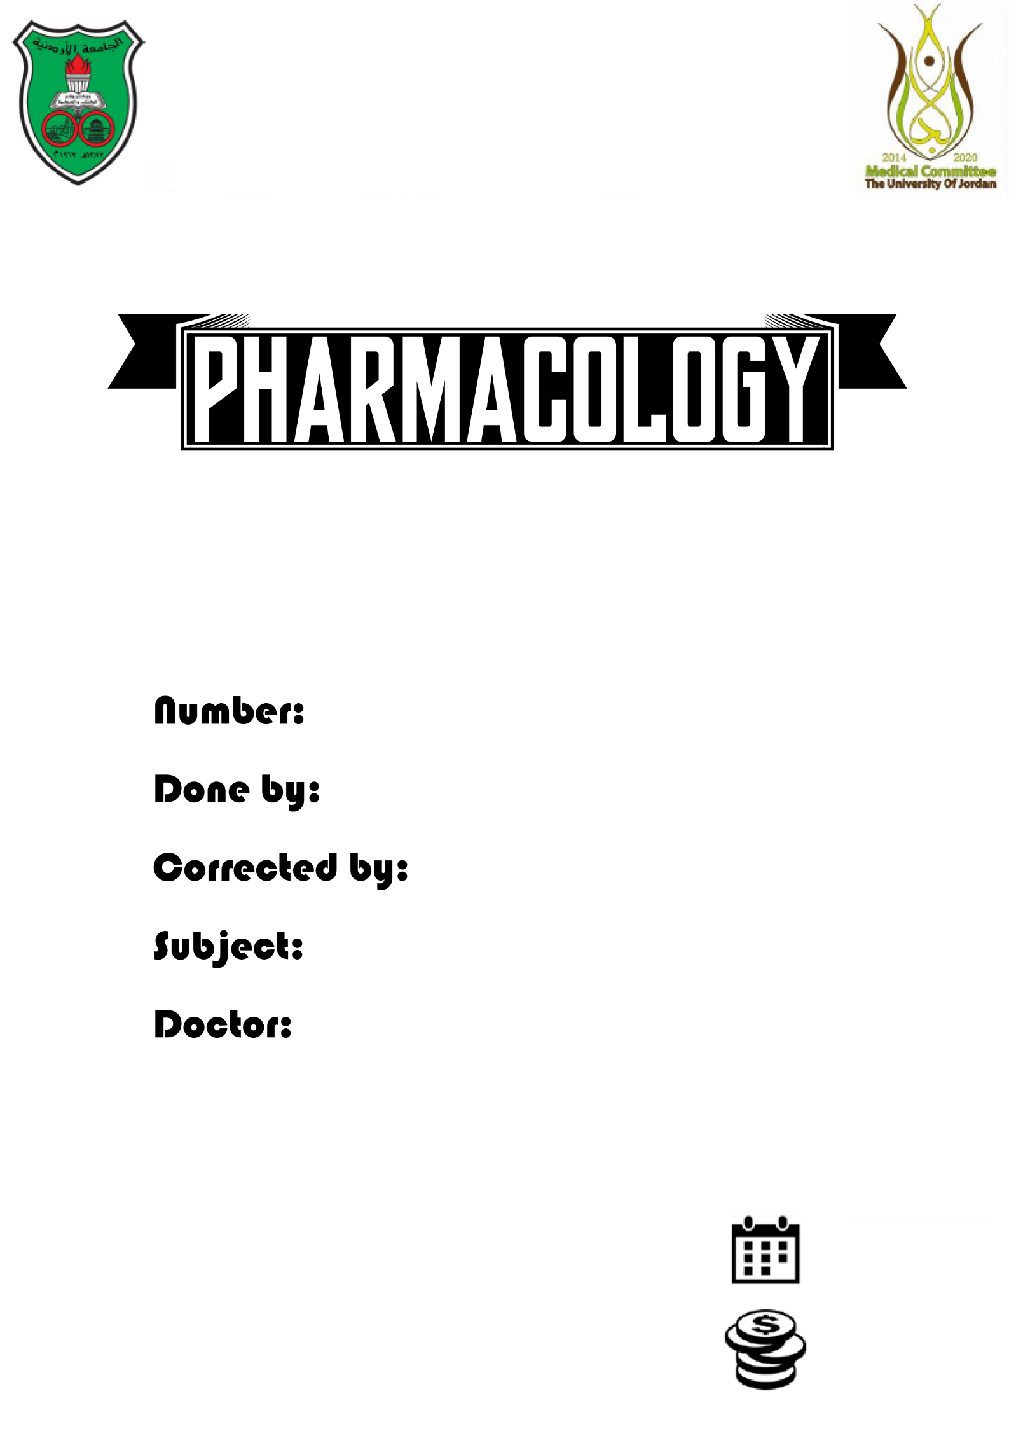

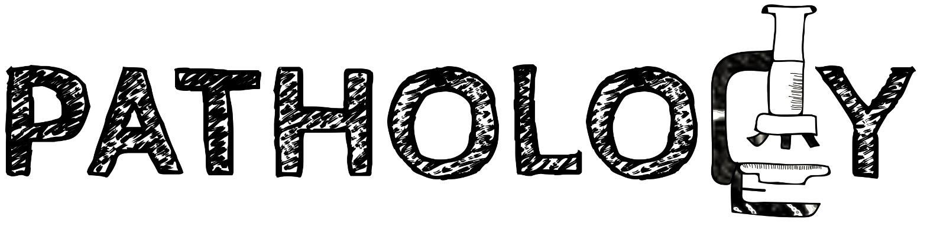

Slides
Sheets

4

Tala Ashour
Mohammad Qussay Al-Sabbagh
Apoptosis
Dr.Mazen

6/10/2015
……..
We talked previously about necrosis,its morphology,and in practice.
Now let's talk about apoptosis :D

Apoptosis:
Originally means “to fall away from “
It's also called “programmed cell death “

** the doctor showed us a figure
at which cells apoptose
What happens? (In general) “these are outlines that are going to be discussed in more details through the sheet ^.^)
- the cell programs itself to die,but rather than spreading everything out, it fragment in small betels called “apoptotic bodies “ these are surrounded by membrane “similar to the plasma membrane “ that's to prevent the component reaching your white blood cells,because intracellular is foreign to our body ,thus it induces our immune system.

- the apoptotic bodies have signals on them that attract the phagocytes to eat them before their contents spell out and cause inflammation
as we mentioned before,apoptosis can lead to necrosis
viruses do the same, they sheall themselves with a membrane similar to the plasma membrane in order not to get identified by the immune system.

** introduction is done :D **

What is “Apoptosis “ ?

Apoptosis is a pathway of cell death in which cells activate enzymes that degrade the cells’ own nuclear DNA and nuclear and cytoplasmic proteins.”
- what enzymes?
Endoneucluases , lipases, proteolases
- it’s similar to necrosis, but in this case it's directed, it's not because of the lack of ATP,instead we are directing the machinery of work in programmed death.

- “a genetically determined process of cell self-destruction”>>encoded in the DNA to synthesize proteins to tell the cell to die!

- “a form of cell death in which a programmed sequence of events leads to the elimination of cells without releasing harmful substances into the surrounding area”

- “Programmed cell death”

Notice that each definition reflect aspects of mechanisms in which apoptosis happens :)

We discussed the morphology of necrosis in previous lecture, now before presenting the differences between necrosis and apoptosis, you have to know the the morphology of apoptosis is very simple..the cell shrinkage, fragment and dies!

Apoptosis Vs necrosis :

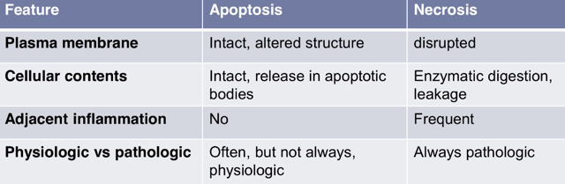
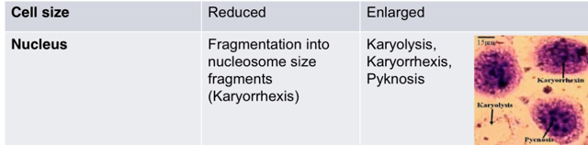

Let's talk about each feature in more details 😅

1)Plasma membrane:
In necrosis the membrane rapture because there is no ATP, the cell can't produce phospholipids,calcium influx activates lipases and break down the membrane,mitochondrial damage produce more ROS which causes lipid peroxidation
Of the membrane. On the other hand , in apoptosis the membrane intact and not ruptured, however it's structure is altered ( we will talk about that)
2)Cellular contents:
Because of the membrane rupture in necrosis the cellular components leak out of the cell and this cause inflammation , and it gets digested by the lysosomal rupture of lysosomes. In apoptosis the cellular contents remain surrounded by membrane of apoptotic bodies
3)Adjacent inflammation: Only in necrosis
4)Physiologic Vs Pathologic
Whereas necrosis is always pathologic, apoptosis can be ether physiological (often) or pathologic.
5)Cell size:
In necrosis cells enlarge as the cell swell and different ion channels stopped working so we get net influx of materials. On the other hand, apoptosis reduce cell size because of benching of bets as apoptotic bodies.
6)Morphology of the nucleus:
In apoptosis the cellular nucleus fragment into pieces that are carried in the apoptotic bodies that's called (karyorrhexis)
In necrosis we see different morphologies:
• karyolysis: as the name implies,break down of DNA, thus making the nucleus less basophilic
• karyorrhexis: fragmentation of the nucleus
•pyknosis :shrinkage of the nucleus

Causes and mechanisms of apoptosis:
- Physiological:
1)PCD during embryogenesis:
- like what happens during cell migration, after cell ditched to migrate, cell which remains die (apoptose)
•what happens if they don't die?
Something called developmental rest of cells, one of the most common developmental rest is ectopic gastric tissue in the esophagus
- making canals in embryo ,basically the cells create a cord (filled inside) then the cells in the middle are going to die.

2)Hormonal withdraw:
- how is milk made?
By lactation,after lactation you withdraw hormones cell that were producing milk are no longer needed , so they apoptose
- at the end of the menestrual cycle, hormone levels decreases, as that happens the cell don't die in necrosis ( you don't want inflammation every menses) so the cells simply apoptose.
3)Steady state population:
when mucosal tissue tare , the cells detach and die
Those are replaced by stem cell located at the basement cell layer.
4)End of function life:
- How you build bone? By ossification of and existing chondrocytes (cartilage)
These cells that first made that cartilage , or cells left without ossification , those die
- when you have infections the number of your white blood cells increases, after you get rid of the infections, the population of WBC decrease as they apoptose
5)Self reacting lymphocytes:
Our white blood cells recognize foreign antigens and don't recognize our cells antigens ( unless in the case of auto immunity),however, how do you create these white blood cells that recognize foreign antigen is actually a process of random genetic rearrangement , so we creat all different chemicals that differentiates one proteins from another,because it's random you could have white blood cells that recognize your cell antigen ,normally these cells are identified and send to be self killed .

- Pathological :
1)DNA damage
2)Protein misfolding / ER stress:
Like prion disease, alzhaimer , parkinson (see Table 1-2 in Robbins basic pathology)
3)Some infections/ cytotoxic T cell induce:
- What are cytotoxic T cells??
Our WBC are divided into:
B-cells (produce antibodies) , T-cells
T-Cells are divided into:
CT4 helper cells( help directing other white blood cells do their work, produce soluble factors that alter the forgien cell)
CT8 cytotoxic T cells( direct cells to kill themselves through apoptosis
For example: if one cell is infected with a virus, it will have pits on its membrane, the cytotoxic T cell recognize these cells ,and direct them to die.
4)Pathological atrophy after duct construction:
Which organs typically atophie if you construt their duct?
PPK: p (pancreas), p (parotid), k (kidney)
These undergo apoptosis rather than necrosis when their ducts are obstructed

Mechanisms of apoptosis ( pathways)
- Mitochondrial pathway:
Also known as “intrinsic pathway “ because the mitochondria is located inside the cell.
- Death receptors pathway:
Also known as “ extrinsic pathway “ because most of receptors are located on the plasmic membrane , however there are some receptors inside.
So what ever the stimulus is “DNA damage, hormone withdraw…etc”you signal through twenty or more proteins that maintain the apoptotic balance
- we have two types of these proteins :
1-Pro-apoptotic 20Anti-apoptotic .
- if we increase anti-apoptotic proteins the cell doesn't die, if we increase the pro-apoptotic proteins the cell dies
- if you signal for these particular proteins to increase in their activities, number, they are going to induce through the mitochondria a leakage of cytochrome C , which can activate other other downstream proteins called “caspase”
Caspases: are cystine proteases that cleave the protein after the ASPartic residue.
protease>>break down of proteins.
cystine protease >>> has cystine in its active site
The death receptor pathway can directly initiate the caspases. The initiator caspase starts a cascade where one caspase activate another which end up in ordered activation of endonuclease and proteases and phospholipases as well!
- proteases break down the cytoskeleton, so it gives small bits
- endonuclease: fragment the nucleus.

Now lets talk about each of the pathways in more details:

A) Mitochondrial pathway:
*mitochondrial permeability is a key here!rather than allowing proton escaping the mitochondria reducing the ATP, it let specific proteins out through a pore or a channel, This channel is called “bax” “bak”, it's normally closed due to the action of Bcl-2!
Bcl-2 was one of the first apoptosis related proteins to be discovered,so all other apoptosis proteins are under the BCl-2 family, there are both pro apoptic and anti apoptotic in its family.
So Bcl-2inhibit the activation of the mentioned pores, it makes sure they stay closed! If any stimulus alter the cell ( DNA damage, hormonal withdraw…)they activate proteins called BH-3,these are sensors that detect the stimulus and damage.
BH3 are called so because they only contain the third sequence of the BCl-2 family, so they are in the BCl-2 family but they are “pro apoptotic “ as they stimulate the bax channel,and antagonize BCl-2 ( BCl-2 are inhibitors, and when u antagonize (inhibit) an inhibitor you activate the pro apoptotic proteins - (سالب السالب موجب ^_^“
- you are inhibiting the anti apoptotic proteins and activating the pro apoptotic proteins >>so you have leakage of cytochrome c , you activate caspase 9,and apoptosis
- notice that you are not only stimulating and activating different proteins, you are also affecting levels of different proteins , BCl-2 levels are reduced due to inhibition and degradation of proteins.
- this is responsible for apoptosis in most of the situations.
B) the extrinsic pathway:
- TNF receptor family are have prototype as FAS and CBF5 , they essentially receive a signal from the outside , the death receptor on its own does nothing, there's a domain inside called “death domain” that mediate binding
For example: FASl “fas ligand” that may be provided by a lymphocyte,that cause triplicate of the receptor as it trimaries, , this makes FAD “FAS associated death domain “
Notice that FAD. Has the same death domain the receptor had but in different depth inside,this activate procaspase (precursor for caspase) to cleave itself and become active caspase 8 ,this activate the downstream executional cascade
Note: there are other proteins that control this process beyond the death receptors, like FLIP proteins that inhibits the activation of caspase 8
Note : some viruses were able to sproduce a protein that mimics the flip proteins and inhibit the caspase 8,therefore if there were an infected cell,and cytotoxic T cell produce FASL to tell the cell to kill itself, the virus will produce flip to inhibit the process and then survive.
- an overlap between the intrinsic and extrinsic pathway occurs,because caspase 8 “activated by the extrinsic pathway “ can activate bh3proteins “which therefore activate the mitochondrial pathway “

FAS,FASL mutation:
These can be the cause of auto immune diseases,it's the same mechanism that's used in self reacting lymphocytes
Abnormalities in cytotoxic T will cause the production of FASl and trimarization of the death receptor and therefore for killing it by the extrinsic pathway.
A mutation in FAS WILL cause these cells not to die, they will attack our tissue
- How do we get rid of the apoptotic bodies?
We mainly use four methods
1-Phosphatidylserine flip (in to out) these are in the inside face of the membrane, when they flip out they attract phagocyte ..
2-Glycoprotein's: they serve as signals for phagocytes
3-Complement: glycocilated proteins, other things produced on the membrane that attract phagocytes
4-Soluble factors : produced by macrophages

Cause and mechanisms in practice:

•Growth factors degradation :this means that sensitive hormone cells miss hormones( we already talked about that)
•un stimulated lymphocytes :let's say that a certain antigen has entered the body, lymphocytes will be produced, if that antigen is never been exposed to, and if the lymphocytes are no longer needed,apoptosis occurs.
•neurons deprived of neural growth factor>>pathological
- what exactly happens?
If you have a survival signal,this activates BCL-2 which closes the BAX channels, thus mitochondria don't leak the cell survive :D
If you take away that signal,this will activate the sensors,the sensors antagonize the anti apoptotic proteins,stimulate the pro apoptotic proteins, open the channel,cause apoptosis.

- DNA damage:
When in the cell cycle the DNA is replicated?
In the s phase
If you want to pause the cell cycle, you pause it at the G1 phase ( before S phase)
There's a protein called p53,if there is a damage in the DNA, there will be accumulation of p53,thus stopping the replication.(G1 block induced by accumulation of p53 caused by DNA damage)if the DNA is repaired, the p53 goes down,the cycle continues.
If the damage wasn't repaired, and it's sever,p53 activate the BAX channel,antagonize the BCL-2,furthermore it actually increases reduction of BAX channel,produces micro RNA (we will talk about later)and cause reduction of DNA repair enzymes,this induces apoptosis .
If p53 was absent, the mutated DNA will replicate even though it's damaged, this will cause canser in some cases.
- misfolded proteins:
Why do we consider them a problem ?
They might be distructind certain functions in the cell, they could be vital proteins, they aggregate and change the morphology of the cell.
What determines the folding of proteins?
The primary amino acids sequence, and chaperones.
What happens first when there's accumulation of misfolded proteins?
The cell will adapt by slowing down the rate of production of the misfolded proteins and start producing more chaperones,if the chaperone can't keep up with levels of misfolded proteins, this will lead to apoptosis. (This is called ER stress)
The proteins get degraded by the adequate lysosomal pathway, cells which use this pathway are cells which normally adapted by atrophy,and if the stimulus is severe>>they apoptose.

- the doctor mentioned a way to overcome the effects of FLIP mechanism, which are Granzymes, these are permeable that can go through the cytoplasmic membrane and activate executional cascades.

- necroptosis:
It's another way to overcome the effect of “FLIP"
For example: you are signaling through TNF receptor,this normally activates caspase 8 , if caspase 8 is not activate, another complex called “necrosome” these will alter the mitochondrial membrane permeability, this will lead eventually to necrosis
This necrosis is a programmed necrosis.

THE END

