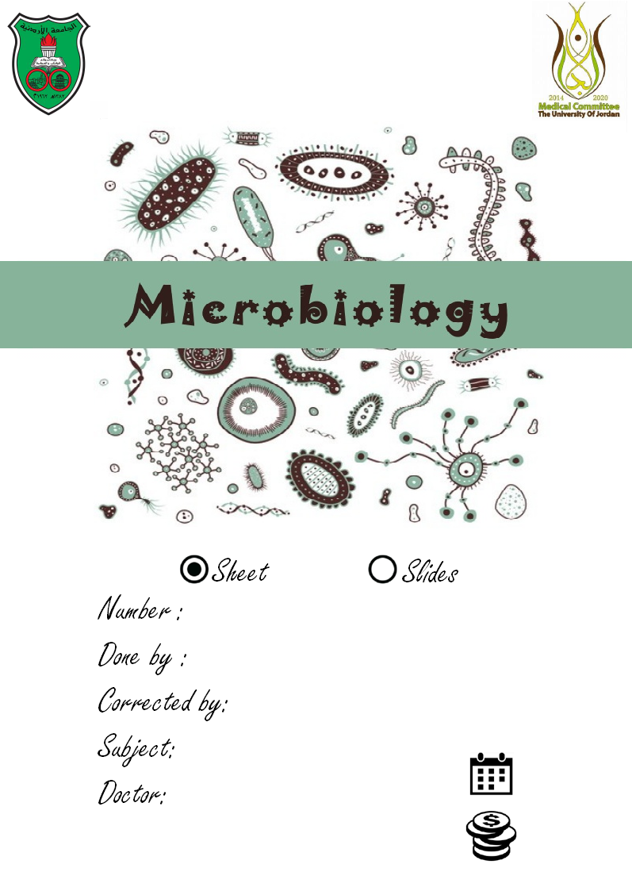

2
Tala Ashour

Mohammad Qussay Al-sabbagh

Introduction to bacteriology
5/10/2015
Dr.Asem + Dr.Suzan
……..
Bacterial cell structure :

- We talked previously about bacteria’s general structure and composition .

- We mentioned that the cell wall is composed of peptidoglycan “ which is carbohydrate linked to peptide”

- The peptidoglycan portion however is NAM “n-acetylmuramic acid” linked to NAG –those two are the carbohydrate” and only NAM is linked to peptide “mostly alanine”

- Notice that we are only studying bacteria for now “we are not talking about any other microorganism”

Knowing the cell composition of gram +ve and gram –ve bacterial cells helps us in understanding the process of infection, because the process of infection related to gram +ve bacteria differs than that related to gram –ve bacteria, due to the fact that each cell structure influences a specific response; once bacterial cells reach our body, they’re lysed, damaged and broken down by phagocytosis and other factors to certain compounds.

For example: Gram+ve bacteria will be broken down to a capsule, a cell wall, many parts of cytoplasmic membrane and the chromosome of the cell. Our immune system responds by producing specific antibodies (against the capsule, against parts of the cell wall and against the other components of the bacterial cell).

Some of these antibodies (which are composed of immunoglobulins) can be identified later by certain laboratory tests.

The most important components of bacterial cells (like capsules, the cell wall, the peptidoglycan layers, flagella and fimbriae) are considered foreign materials or antigens. These foreign materials will stimulate our immune response to produce specific antibodies against them. (So antibodies against capsules, antibodies against the somatic antigen)

- In the previous lecture We mentioned “gram stain” and accordingly we have gram +ve bacteria “those appear violt-dark blue under LM, as they have up to 80 layers of peptidoglycan” and we have gram –ve bacteria “and those appeare red as they have two phospholipid bilayer one is the plasma membrane and the other is outer membrane and their peptidoglycan layers are only five “
- The outer mambrane (which occures in gram –ve bacteria ) is very similar to the plasma membrane ,however there's a difference, the outer membrane consist certain molecules called –lipopolysacharades- and these don't present in the plasma membrane “notice that we only have them on the outer membrane of gram –ve bacteria “

- Lipopolysacharades: are macromolecules consist of lipids and carbohydrates. They are called endotoxins ,which means that they are a source of toxicity “for humans” the disease they cause is called “endtoxic shock”,”septicemia “,”enceptic shock”.these terms indicates that we have LPS “endotoxins “ in the blood.

Since these structures are only found in gram-ve bacteria,so we can't have it without being infected with it.the term “septicemia “ means that we have the bacteria and the endotoxin in the blood stream!

- LPS: the lipid moiety is called lipid A, and the carbohydrates are referred to as “O antigen ” or “somatic O antigen” .

- The toxic part “the one that causes septicemia “ is the lipid ,not the carbohydrate.so if we break down an LPS molecule and injected one patient with lipid and the other one with the carbohydrate,the patient who was injected with the lipid portion will develop the symptoms of endotoxic shock!

Shock symptoms: fever,shivering, sweating,increased heart rate,low blood pressure,low sugar “hypoglycemia “,active coagulation cascade, increase bleeding.

Usually in coma we have two activated cascades , coagulation and bleeding .all previous symptoms can be fatal if not treated,as they cause chaos in the host body.

Now let's continue talking about the “endotoxins” , the somatic O antigen is significant for diagnoses,as we have anti-O antigen that we use to find the bacteria.we can also identify which kind of bacteria the patient is infected with, as we have different o-antigent with numbers, so if the patient is infected by E-coli we can identify it by using specific ant o antigen7 ,we conclude that it cause certain types of disease. As conclusion, we use different antigens as markers for the bacteria.

- Since we have classified bacteria according to “gram strain” let's now mention some examples:

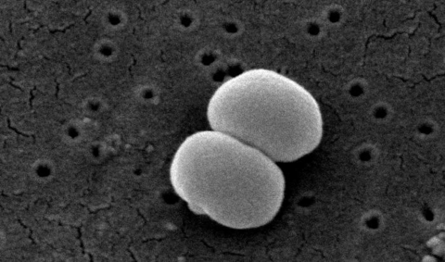
- Gram +ve bacteria: staphylococcus aureus(العنقودية) , epidermidis “shown in the picture :) “ ,streptococcus,bacillus .(These are the genera –genous- are gram+ve)

- Gram-ve: E-coli,(klebsiella,salmonella,pseudomonas)>>same family.

In gram +ve we have certain molecules which are not found in gram –ve bacteria,like teichoic acid and lipoteichoic acid ,and these are significant as they can be used as markers to identify the bacteria ,they also aid in the adherence of bacteria to surfaces,also acquiring some kinds of ions (because they are charged to they can attract Mg ,or after adhering to a salt and then acquire the ions)

If we treat gram +ve bacteria with enzymes like lysozyme “in tears” , we produce it naturally in our tears , we are protected.

- What do lysozymes do?

It dissociate the peptidoglycan found in bacterium cell well, so it loses its integrity,so even water sported inside the bacteria will make it burst (die😩)

Note : In the lab, when it's difficult to deal with the bacteria because of its rigid cell wall, we treat it with lysozymes, and then menibulat its genetic material for example .

- The gram +ve bacteria without its peptidoglycan is referred to as “protoblast”

- Gram –ve bacteria,can be treated with lysozymes,but without its peptidoglycan it's referred to as “spheroblast”

The difference between “protoblast” and “spheroblast “ is that the protoblast is surrounded with one membrane while the spheroblast is surrounded by two membrane “the outer membrane and the plasma membrane “

let's countinue talking about the bacterial cell structure

1-Cytoplasmic membrane

Cytoplasmic membrane “plasma membrane “:phospholipid bilayer, whith the hydrophilic portion facing outside and hydrophobic portion facing inward.it’s important as it helps for binding of enzymes, and the membrane transport proteins which aid in the transportation of materials in or outside the cell.We also have permeases which permits the transportation of materials.

Inside the cell we have different kinds of granules, phosphate containing or sulfur containing, or other materials.

2-bacterium genome:

Inside the bacteria cell we have nucleic acid in both DNA ,RNA forms 🌀, the actual genetic material is mainly in the chromosomes “remember that the bacteria is haploid cell, meaning that it has a single chromosome”.this chromosome is circular,double stranded,and it's formed by DNA.

However, we do have other genetic material insid the cell, called plasmids, these are multiplied independently from the chromosome,they are very small when compared to the chromosome,they carry genes responsible for antibiotic resistance (but only some of the genes we aslo have genes for resistance on the DNA) ,acquiring nutrients

Some genetic materials are acquired by the bacteriophage, which is a virus that can transfer genes to bacteria ,mainly these genes are DNA,but we also have RNA bacteriophage, the bacterium should have enzyme to convert the RNA into DNA. The transferred genes are mainly toxic,not to the bacteria itself but to the host body that get infected so if harmless bacteria get genes from bacteriophage, these genes will be expressed into toxins that would cause the disease to the host.

Notice that the DNA. In the chromosome is for bacterium requirements like structure, plasma proteins, while plasmids are for more developed features, so it's easier for the bacteria to deal with it because it's smaller than the chromosome.,also the structure of plasmids make ut easier to insert genes.as a conclusion, bacteria supjected to evolution is those which have plasmids.

3-Flagella:

- Bacteria don't have cilia!

- Their flagella is totally different than the eukaryotic flagella( which is composed of microtubules, arranged in 9+2 doublets), in bacteria the flagella is simply proteins like fibers,the motion is also different! In eukarya it pumps like the snake, but in bacteria it moves like motors (circular), the length is shorter.

- Bacteria can have singular, two, many flagella with different arrangements “please refer to the slides :D”

- This flagella contain antigen called “H antigen “ , it's important in diagnosis and identify the bacteria.(20)

4-Fimbrae and pili :

They are not the same,and some books mistakenly referred to both of them as if they were the same.

- Fimbrae are small appendages found all over the bacteria ,they are short,and used for adherence , composed of fimbrin

- Pili:different type of protein called pillin,few (2,34) ,long,not all bacteria have pilli. Those which have pilli are capable of certain DNA recompenation called “conjugation “it acts as a bridge, that transfer certain genes after being copied to adjacent bacteria “adhered to” , the second bacteria will get new genes, this is conjugation.”it's referred to in book as sex pili because of this recompenation, but it's not sexual reproduction “

NOTE : in the conjugation process one of the bacteria has pilus but the other doesn't, if certain genes were transferred to it and responsible for forming pilli, the new one will form its own.

- We have antigen called “F antigen” in fimbrae, and we have “P antigen” in pilli ,

5-Capsule:

carbohydrate above the cell wall of the bacteria,if it's rigid we call it capsule, if it's slimy we call it slime (but both of them are composed of carbohydrate) .it also aids in the adherence of bacteria to tissues .

The most significant characteristic that bacteria with capsule have, is that it has anti phagocytic defense,so white blood cells can't phagocyte the bacteria with capsule, unless it's covered with antibody, if it has the antibody it can be phagocytized.

The capsule has antigen called “K antigen “>>>salmonella has capsule , but when they discovered it they called it “VI antigen, virules antigen “ only salmonella we refer to its antigen as vi antigen.

We have infections called “biofilm infections, biofilm related infections “,these are caused by bacteria that can produce high amounts of capsule or slime,these can adhere to the implanted devices like heart vulve,joints,vocal cords devices..etc.so as a kind of defense the bacteria cover itself with extra layers of capsule,these infections are very dangerous as they are difficult to treat,and can be fatal as antibiotics don't work on it.
Q: How do doctors treat patients with biofilms?

They take out the implant , give the patient antibiotic and then put back the device “because these bacteria when they are no longer in biofilms can be killed with antibiotics” this is why it's better to prevent these kind of infections rather than treating them.

- We also can find biofilms on teeth of people who don't brush their teeth regularly “between the gum and the teath” (اللون الاصفر)so if u don't brush your teeth regularly your teeth will get decay (تسوس)

6-Ribosomes:

70s ribosomes similar to us but smaller,used for synthesis of proteins,

7-Mesosomes

infolds of the plasma membrane, we find different kind of enzymes,mostly enzymes for binary fission, so when the bacteria divide it starts from the mesosomes.

We can find different kinds of granules,lipid granules,polysaccharides,sulfur,phosphate. We can identify the bacteria according to the type of the granules,(ex if corynebacterium has phosphate granules, if we use special stains to detect these bacteria we look for those wich show positive results for phosphate granules)

- Virulence factor:

What we talked about previously can be referred to as “virulence factor” like when we have a bacteria with capsule is anti phagocytosic , so the capsule is considered virulence factor.

In order to know the difference between various types of bacteria we have to know what those types of bacteria produce of specific types of enzymes, toxins, or other fragments and appenditions as adhesion proteins in relation to fimbriae , to pili … any of these harm factors might contribute for enhance of pathogenicity of bacteria and might be associated with development of clinical case and infection whether in our respiratory path or skin or other parts of body .. Each bacteria has specific harm virulence
factors .
- The structure of these proteins helps the bacteria in colonization “some of them” by adhering each one to another.

- Some of these proteins are immunoevasion,they can nutrilize the immuno response .

- Other proteins are Immunosuppresion,تثبيط عمل جهاز المناعة

- Some of them can use virulence factors as a way to enter the tissue or the cell.

Growth of the bactria : It doesn't mean the increase in size or function, but it is the increasing of number of the cells. For example, instead of having 1 cell, you can have 1billion cells in order to recognize the growth of bacteria, and this can happen in less than 18 hours if we offer the necessary conditions (water, growth conditions, and oxygen). So if bacteria is cultured in favorable conditions it will undergo rapid continuous division, for example it’s been calculated that 1 E.coli cell if cultured in favorable conditions might produce (within 24 hours only) 1 ton of bacterial cells.

- Endospores

In general gram+ve and gram –ve bacteria can’t survive for a long time, and must always produce new generations/cells. But there are some types of bacteria found in nature and might also be found in our intestines called: spore forming bacteria (usually they’re gram +ve bacilli). They manage to survive under harsh conditions (lack of nutrients, water, etc)

- Spore forming bacteria ,endo spore forming bacteria,special kind of bacteria,only some kinds of gram +ve rods can produce endospores (ابواغ) they use it as a way of reproduction ,since they can't undergo sexual reproduction,so endospores are a way established to protect and maintain their generations,

- Let's say that we have a pool with a kind of bacteria and we treat it with antibiotics, when the bacteria is threatened it produces endospores “only those who can”

- Endospores: produced by vegetative cell,gram+ve rods “some of them” they copy the chromosome,then they take few ribosomes,and surround these by a plasma membrane,on the plasma membrane we find different kinds of salts (calcium salt) “calcium is mostly found in stones,so it makes the membrane more rigid to protect all these components,until the environment become safe, the endospore will grow into the actual vegetative cell.

- To get rid of these endospores you need high temperatures “you can't get rid of them by boiling or cooking or freezing “u treat it with 121 c for 15-20 mins with high atmospheric pressure!

- Food poisoning from canned food is possible if it wasn't treated properly, as the endospores are not dead!

- We have two gram +ve rods bacteria that can produce endospores :

1-Aerobic bacillus 2-Anaerobic clostridiums

the doctor mentioned the dead sea poisoning story,a year ago,by bacillus serrous which produces endospores.

- Clostridiums:

- Tetanus disease ,can be caused if a wound is contimenated with soil,thst contains the endospores, which will germenate the cut with the actual bacteria which will produce tetanus toxins (الكزاز)

- Botox: botulinum toxin is a very dangerous toxin,it's fatal in its nano gram concentration,that's why botox filler are dangerous

Binary fission:

Binary fission: a process by which one cell can give two cell which are totally identical, and similar to the original cell.for one bactrial cell to give me two , the time duration is called “generation time”

Generation time: the time required for one cell to develop into two, and different types of bacteria have different generation time , most of them need 20-30 mins

- E-coli needs 20 mins

- Mycobacterium tuberculosis needs 18 hours (بكتيريا مرض السل)

